The Impact of AP Requirements on Student Mental Health and Academic Performance

Word Count: 4822

**Introduction**

The transition from middle school to high school for the majority of adolescents can be an experience of declining mental health and academic functioning. Coupled with rising workloads, new environments, and different expectations to fulfill, adolescents find themselves working with unfamiliar situations (Suldo, 2009). The individuals who choose to complete accelerated curriculum learning enter programs such as Advanced Placement or International Baccalaureate courses. These programs are on par with college level courses and require their participants to engage in accelerated course load; structured to provide high school students an early introduction to college-level classes whilst accumulating college credit during their high school years (Jin, 2008). Studies have noted the introduction of negative impacts on psychological functioning of participants. Psychological functioning concerns the ability of an individual to achieve their internal and external goals, including: behavior, emotion, social communication, and mental functioning (Suldo 2013). In order to put this into perspective, studies have noted that junior high students’ adjustment into high school and AP/IB courses reflect a drastic contrast between their previous social/psychological functioning, signaling a possible domino - causational - effect.

Through the majority of adolescents' school experience, transitions from one grade to another had not exceptionally varied in workload or environment. The most pronounced transition existed between elementary to middle school (Benner, 2011). For AP students, the transition into high school and AP’s are more pronounced than their general peers. In accordance with Suldo and Jin, these individuals find themselves facing non-stop workloads, excessive learning outside of class hours, and preparation for end-of-course exams on top of the numerous environmental stressors associated with high school. Aside from academic challenges, students have exhibited negative behaviors and signals towards psychopathology; these including “depression, suicide, and substance abuse,” or rise in perceived stress (Suldo, 2013). To date, the existing information on the associations between stress and student functioning for high-achieving individuals is under-examined. The basis of rigorous college-level course requirements that attribute emotional impacts on student’s mental health and reflect on their academic success will be pursued through the testing of correlations between various factors of mental health existing within a large urban high school’s AP small-learning community.

**Literature Review**

**Forced Choice Dilemma: Defining Success**

Defining success varies per character. Individuals hold their own set of values and expectations and react differently in situations calling for excessive demands. These college level programs remain for the most part inflexible with the number of required courses, essays, tests, and projects set to be completed within a certain timeline unchanging despite changing factors or circumstances within their participants (Foust, 2008). In a study conducted by analysts, taking the two most common methods of serving AP-involved students, they formed theories regarding “the Forced Choice Dilemma” (Foust, 2008). The Forced Choice Dilemma focuses on students choosing between the needs for social endeavors or academic achievement; whether they felt forced to choose between having academic success or a social life.

While this seems like a normal occurrence within the student community, the added responsibilities and pressures attributed with AP and IB programs result in participants suffering from perceived positive and negative social/emotional consequences – “deepening the ongoing stereotype surrounding AP and IB students” (Foust, 2009). The research reflected the ongoing negative stereotype that reinforces the socially limiting workload associated with AP courses; however, Foust reported that despite the unflattering stereotypes, stress, fatigue, limitations placed on class choices and extracurricular activities, “AP and IB students did not consider academic success a choice” instead noting that they possessed the ability to “ maintain both a social life and academic performance” (Foust, 2009). Prominent throughout the academic work, the concept of having it all – both social and academic success – required participants to sacrifice. Sleep was relayed as the easiest sacrifice for adolescents, established as a frequent constant. The frequency of mental health problems had become more apparent, derived from participants' sacrifice to maintain a normal life on top of their academic pursuit.

**Coping Strategies And Sleep Propensity**

Investigating the association between sleep deprivation and those participating in AP programs, the majority of students were sleep deprived. Those involved in AP and IB courses had slept approximately 20 minutes less per night in comparison to their general education peers (Jin, 2008). The gap between sleep time deepened with the progression of grade levels, reflecting increased requirements associated with taking on more advanced classes. Qian Shi further expands on Qiushuang Jin’s work, noting that 9-10th grade AP students slept approximately 1 hour and 40 minutes less than their peers while 10th-11th grade AP students slept approximately 1 hour and 50 minutes less (Jin, 2008). A general understanding could be drawn: sleep deprivation was a recurring factor amongst high school students. Pursuing AP requirements and social interactions, the lack of sleep within individuals granted a high probability of causing “impairment of daytime performance, academic performance, and negative psychological symptoms” such as anxiety, stress, and depression (Suldo, 2008). In a causational domino effect, students can find themselves fatigued, burned out, and feeling alienated.

With the rise in alerting factors of deteriorating mental health within high-achieving accelerated course load students, the exploration of coping strategies and sleep propensity became more urgent. Sleep propensity is the ease of making the transition from “alert wakefulness” to sleep under numerous circumstances and variables (Howell, 2004). While there are various styles of coping, the most common is emotion-focused coping where an “individual engages in activities to alleviate the emotional distress caused by a stressor” (Lazarus & Folkman, 1984). Researchers have found that some advanced students, suffering from too many demands for their time, still pursued involvement in a social life. Coleman suggests that some perceived pursuing both academic and social acceptance as social stressors — factors hindering social interaction — while others identified it as their coping strategy (Coleman & Cross, 1988). Focusing on advanced students participating in IB programs in high school, researchers identified the most common coping mechanisms present. The high-achieving individuals coped with the crippling stress through “seeking social support of ventilating their feelings' ” (Patterson & McCubbin, 1987). Aiming to highlight any existing interrelationships among stress, coping, and mental health” (Suldo, 2008), the action of tying together various indicators of student academic and social-emotional functionings, revealed distress amongst students and the severity of internalizing and externalizing problems (Suldo, 2014).

**Sources of Stress in High School**

Studies have collectively understood that the primary source of stress experienced by AP and IB students were related to academic requirements. AP students found themselves balancing expectations, “high levels of perceived stress, reduced academic functioning, symptoms of psychopathology” – study of mental health disorders — extracurricular activities, as well as pursuing social connections (Suldo, 2009). Accounting for the variables associated with participation in AP courses, students were exposed to various stressors associated with relationships, environments, and psychological adjustment.

According to Suldo and other studies who have mentioned this concept, students could either be academically successful and a social outcast or socially successful and an academic underachiever (Suldo, 2014). Taking into account the acting factors of perfectionism, cognitive and emotional intensity, and interactions, Foust alongside Suldo agree that advanced students tended to attempt to cultivate relationships with their peers but data revealed that pursuing both requires “extensive time and effort” resulting in taking time away from the other if pursuing one (Foust, 2008). In detail, the trend of perceived stress is dealt with through students seeking emotional tension release through verbal venting through peers that can relate to them. These relationships are limited and tend to be confined to a few peers. Adolescents entering high school are faced with new expectations, teachers, organizational structures, and a larger student body, stimulating stress. A group of researchers mentioned that advanced students suffered from differable levels in life satisfaction in accordance with academic achievement and educational experience in general (Shaunessy, 2006). Coupled with pressures of achievement and expectations both at school and within advanced students’ households, perceived stress is further intensified with the rigorousness of AP programs. Exploring the extent of advanced students’ responses to academic stress, some researchers measured five factors of academic stress: pressure from study, work load, worry about grades, self-expectations, and despondency – loss of hope or courage (Subramani, 2017).

Stress contributes negative emotional, cognitive, behavioral, and physiological stressors that hinder individuals’ abilities to perform or function (Subramani, 2017). Some studies highlight students’ varied psychological adjustment during the transitional period from junior high to high school. The concept of perceived stress and academic adjustment is emphasized with advanced students needing to pursue a strong work ethic, high accolades, effective task management, and support from peers, parents, and teachers. The requirements of AP courses align with the academic wants of their participants; however, they can branch off into negative reports of deleterious social-emotional outcomes, sleep deprivation, cognitive withdrawal, fatigue, distress, and self-isolation (Shaunessy, 2015).

**Hypothesis**

The researcher speculated that the greater the accumulation of AP courses and their requirements students held, the more frequent negative factors of mental health – including social and cognitive functioning – would be present within the population, resulting in academic performance deterioration.

**Method**

The study called for a mixed – qualitative and quantitative – correlational research approach in order to comprehend the extent of influence requirements of rigorous college-level courses extended over high-achieving students’ mental health; whether or not it extended to have detrimental effects on academic performance. A quantitative method was used to account for the general statistics and test for whether response frequencies aligned to the data points within the existing body of research through a survey that required the collection of statistics regarding perceived stress ratings, self-efficacy ratings, sleep percentages, mental health detriments, homework facilitation, and homework completion. A qualitative method was undertaken to establish whether an adamant association exists between prominent variables exhibited by the specific participant population. The qualitative data involved face-to-face interviews to facilitate an environment that promotes free expression, having encompassed and does not disregard emotions nor personal opinions that survey responses may have garnered. In terms of the correlational portion of the research the Pearson Correlation Method was undertaken. The correlation coefficient was calculated through a function within Microsoft Excel in which a number closer to -1 represents a negative correlation while a number closer to 1 was a positive correlation. A number closer to 0 represents no relationship between the two quantitative variables. The correlation method was meant to highlight any existing relationships between AP course requirements and AP students’ mental health and identify the strength of said correlations between lower academic performance, variation in workload completion, and frequency of certain factors and opinions existing within the chosen population. The researcher drew from each portion of the research in order to make a conclusion on the most prominent factors existing in students’ mental health and apply them in the future to avoid recurrence and promote collected functionality – mentally and physically.

In terms of the study, the quantitative correlational analysis was laid out in accordance with the researcher’s target audience and required consistency within the collected data to assess mental health factors and their frequency within the study. The researcher chose to take data from a singular high school to eliminate excessive variation of circumstances - lifestyle, teaching, and acting factors - on the participants (Suldo, 2008). The research was conducted with data based on experiences from 2018 to 2022, exemplifying the average four years for high school completion. Taken data from students involved in learning communities that facilitated high participation in AP courses, the researcher extended the range of collection to encompass the entirety of the grade levels – 9th through 12th – in response to the method undertaken by researcher Regan Foust in the paper, “Students’ Perceptions of the Social/Emotional Implications of Participation in Advanced Placement and International Baccalaureate Programs”. Based on the acknowledgement in the study, the researcher chose to pursue the range of responses to understand the differences in experiences as the duration of experiences within AP courses had a possibility to result in variation between stress exhibited by upperclassmen, who had already gone through multiple rounds of rigorous workload, compared to those entering AP programs. The researcher administered a survey directed only to a large urban high school, but despite having a target audience, responses were not limited to the school’s most rigorous learning community. To discover whether certain factors only applied to the school’s most demanding program, the researcher did not limit the survey to just that community within the high school but also took from general education students while only including responses which had substantial amounts of AP course completions to maintain data that held responses from students undergoing similar learning environments for validity and reliability purposes.

To yield reliable data, the survey was broken down into 3 parts with the first focusing on individual’s perceived stress levels which was used by Shannon Suldo in “Changes in Stress and Psychological Adjustment During the Transition to High School Among Freshmen in an Accelerated Curriculum”. It was scored based on a 5-point scale (e.g., 0 - Never, 1 - Almost Never, 2 - Sometimes, 3 - Fairly Often, 4 - Very Often) and was used to demonstrate the strong internal consistency and validity through large correlations with indicators of students' mental health (Suldo, 2013). The assessment served to capture how unpredictable and overloaded the students’ found their lives. The researcher synthesized their version of the preexisting question template and scoring rubric for the Perceived Stress Rating Scale. Scores ranged from 0-120 points with higher scores reflecting higher perceived stress (Suldo, 2009). The statistics were categorized through data charts and tables for visualization correlation purposes. The second part focused on an individual's self-efficacy which served to identify the perceived ability to succeed in school and demonstrate appropriate learning behaviors – scores on this portion of the survey were correlated towards emotion, optimism, work satisfaction and identified with depression and anxiety (Shaunessy, 2006). The rubric was synthesized to score based on a 4-point Self-Efficacy Rating Scale (e.g., 1 - Strongly Disagree, 2 - Disagree, 3 - Agree, 4 - Strongly Agree). Scores ranged between 10-40; a higher score indicated more self-efficacy. The third part focused on an individual’s personal experience within their small-learning community and AP courses. The assessment was meant to analyze frequency amongst factors concerning mental health – depression, anxiety, fatigue, burnout, etc. – and identify trends amongst mindsets towards academics. All data was separated into their own corresponding sections for organizational purposes and granted the researcher to visually identify the frequency of factors attributed to involvement in pursuing rigorous college-level programs.

In order to obtain data that did not disregard emotions nor personal opinions that statistically-structured data collection methods commonly do, the researcher facilitated face-to-face interviews to collect qualitative data to better explore the research participants’ opinions and gain insight that is limited in surveys. It was also meant to test the prominence of “The Forced Choice Dilemma” within the population. Surveys served as the general basis for the study, making up the numbers and frequencies of certain variables that were collected through multiple choice – responses were limited to the choices made by the researcher to be included in the survey while the interview questions were open-ended questions which allowed for in-depth and more personal information to be obtained. Originally derived from Holly Davis in her paper, “Having it All at Sleep’s Expense: The Forced Choice of Participants in Advanced Placement Courses and International Baccalaureate Programs”, the researcher structured the interviews as individual-focused towards the high school’s advanced curriculum community – students who were eligible but did not participate in the school’s rigorous AP stressing community were also interviewed individually to increase the opportunity to uncover themes emerging through data analysis and identity certain trends (Foust, 2008). Drawing from Foust’s method, the researcher audio-recorded the interviews and transcribed them later on to prevent mistranslation of participants’ views from speech to paper. The researcher chose to take approximately 10 interviews from the senior population alone – their duration of experience more impactful in highlighting commonality in mental health responses and factors – and 8-10 from the remaining three grade levels. The validity of the Forced Choice Dilemma was recorded through tables which provided a visual comparison of the frequency and alignment of whether or not the students were academically successful and a social outcast or socially successful and an academic underachiever. The responses taken from each portion of the research were analyzed and separated into their respective categories concerning frequency, function, and academic performance. Analysis was necessary in order to establish the most frequent variables, what those variables were associated with, and whether or not those variables could be removed with alterations made to the composition of AP courses.

**Results and Analysis**

Reiterating prior information, the survey tested participants’ perceived stress level, self-efficacy, and response to academic pressures. The survey data reflected 57 participants: 37 seniors, 11 juniors, and 9 other underclassmen. Of the 57 – 72% were part of the high school’s most rigorous learning program. The researcher had predicted that the impact of rigorous AP requirements would downplay students’ academic performance and had chosen to take the current status of participants' GPA at the end of the first semester to allow assignments to have accumulated and to identify whether the requirements reflected on their academic report as a whole. Accordingly, 50 students possessed a 3.5 and/or higher GPA. To test the researcher’s prediction regarding high perceived stress being associated with AP requirements, **Figure 1** reports participant’s GPA with their corresponding Perceived Stress Evaluation score.

**Figure 1: Perceived Stress Evaluation**

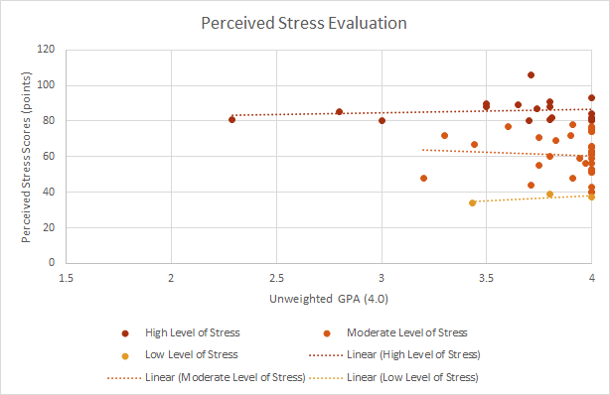

The data revealed that 31.5% of participants possessed high levels of perceived stress, 5% held low levels while 63.5% of participants exhibited moderate levels. Calculating the correlation coefficient, the relationship between academic performance and stress was a weak negative correlation of -0.23322; indicating that when perceived stress increases, academic performance, in this case GPA, tends to decrease but in an unreliable manner. By measuring the degree of how participant’s react towards demands that exceed their ability to cope, the researcher in essence

established a possible correlation between demands of AP requirements and perceived stress. Having further tested the extent of AP requirements’ on the small-learning community, participants’ GPA with their corresponding Self-Efficacy score are displayed in **Figure 2**.

**Figure 2: Self-Efficacy Evaluation**

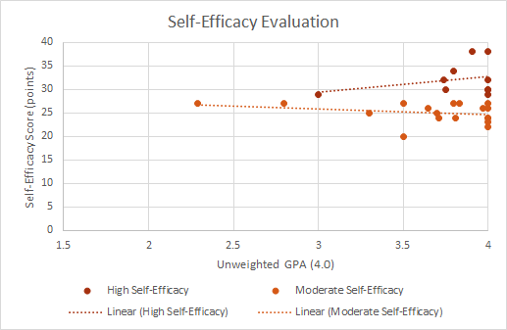

The assessment summary revealed that 38.6% of participants held a moderate self-efficacy while 61.4% possessed a high self-efficacy. Generally, moderate amounts of stress are associated with peak cognitive performance, and high amounts of stress are with poor performance contributed from too many acting pressures to control coping mechanisms. The results from both evaluations neither refutes nor proves the curved relationship between stress and academic performance within the participants’ small-learning community as the correlation coefficient was 0.196529 - at most a weak positive correlation.

As shown in **Figure 3**, participants logged their average times dedicated to completing their assigned work. Of the participants, 37% averaged between 4-7 hours of homework completion, 44% averaged 2-3 hours, and 19% came in with 0-1 hours. A follow-up question was made to determine whether the work completed was deemed busy work, work that keeps a person busy but holds little to no value. 91% reported completing a majority of busy work, signifying a possible reason behind the average homework completion times within the surveyed population. In exploration of possible communication between homework and sleep, participants reported their average daily sleep. 38.6% received between 5-6 hours of sleep per night, 50.9% logged 7-8 hours whilst 10.5% obtained 3-4 hours or less daily. The time spent completing homework and average sleep per night held a correlation coefficient of -0.28105 indicating that when homework time increases, daily sleep tends to decrease and vice versa. The coefficient further identified the presence of sleep deprivation and its relationship with AP requirements.

**Figure 3: Average Homework Completion Time and Sleep**

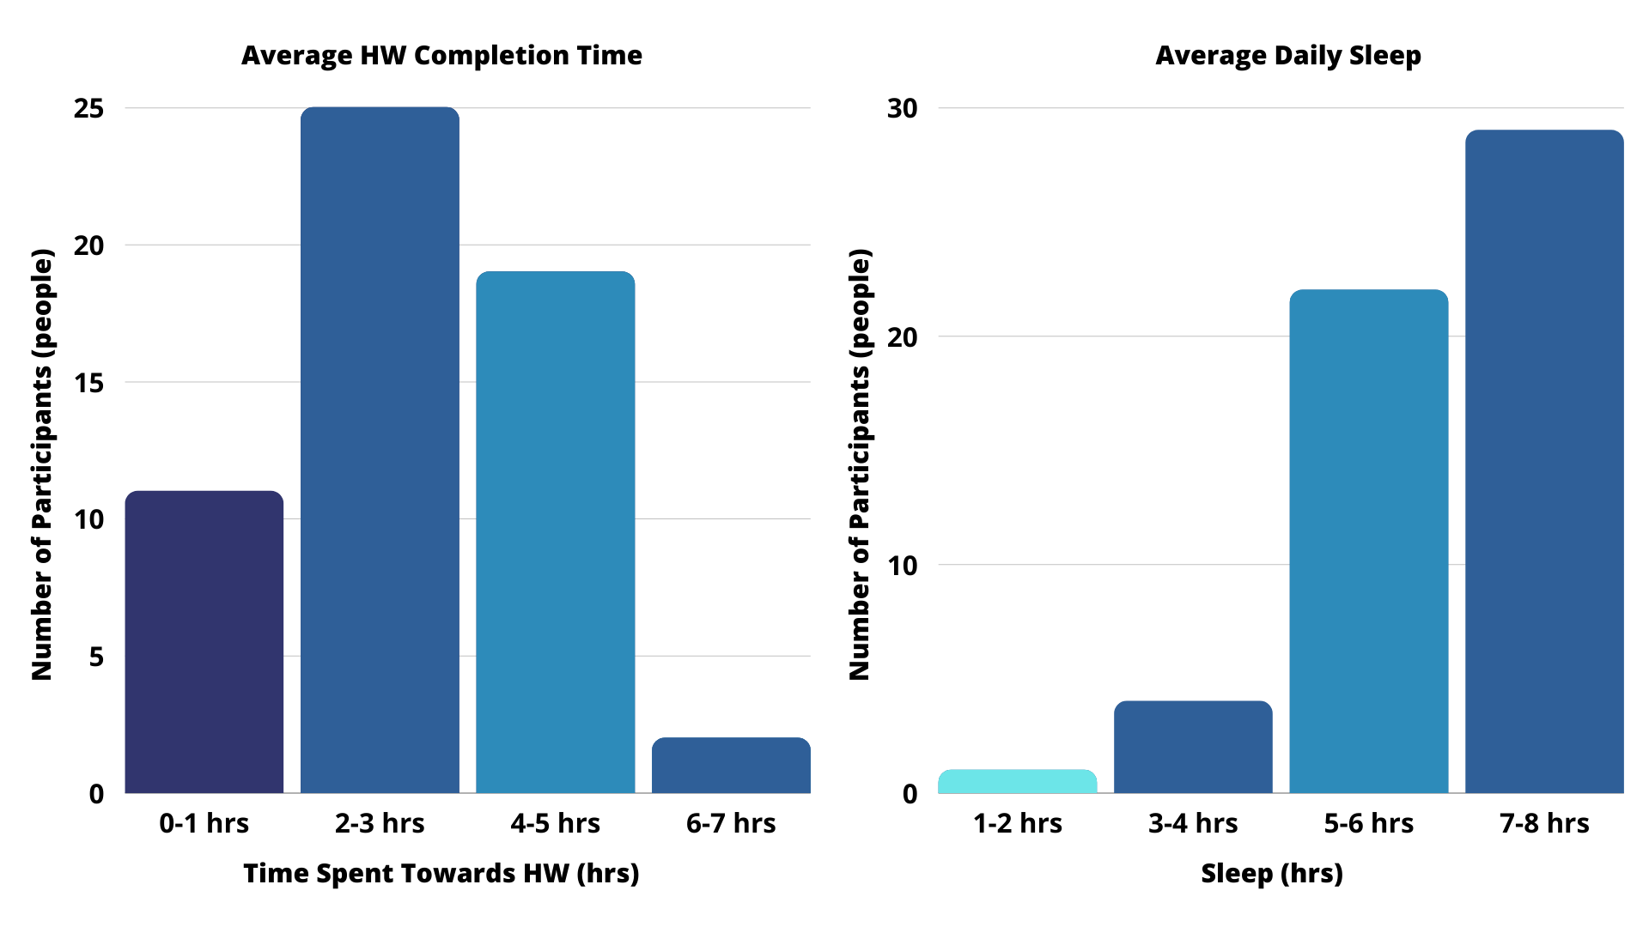

The American Academy of Sleep Medicine has conducted studies which revealed the average teen, ages 13-18 years, should be sleeping 8-10 hours per day. Sleep helps improve adolescents’ cognitive functioning and academic performance when completing school work and other activities; however, from the results of sleep per week, only a single participant achieved an average of 40-45 hours of sleep per week – the caveat being that they are not part of the school’s rigorous learning pathway. Having made the assumption that participants would not be fielding the adequate amount of sleep, the researcher further identified other causes which may add additional schedule and sleep pressures aside from AP requirements – extracurriculars. 100% of participants were involved in some form of extracurricular within and/or outside of school. Approximately 72% reported an impact on their study time, quoting late practices leading towards late nights to finish assignments. For student athletes in particular, 9-11 hours of sleep is required for them to attain optimum cognitive and active performance. Not a single student-athlete logged the 9-11 hour sleep interval, much less 9 hours of sleep daily in general, signifying the acting impact of lack of sleep regardless of all the responsibilities present within the survey’s population. The researcher wanted to account for other factors; noted through the interview segment of the data collection, 33% of the interviewees admitted to procrastinating. This question builds on the types of psychological impacts AP requirements hold on the student population. Procrastination can be attributed to individuals’ perfectionism, lack of motivation and fatigue, or being afraid of failure.

**Figure 4: Interview Responses - The Forced Choice Dilemma**

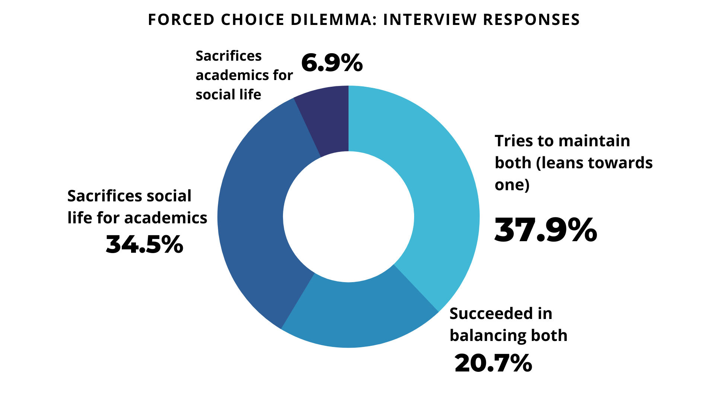

**Figure 5: Survey Responses - The Forced Choice Dilemma**

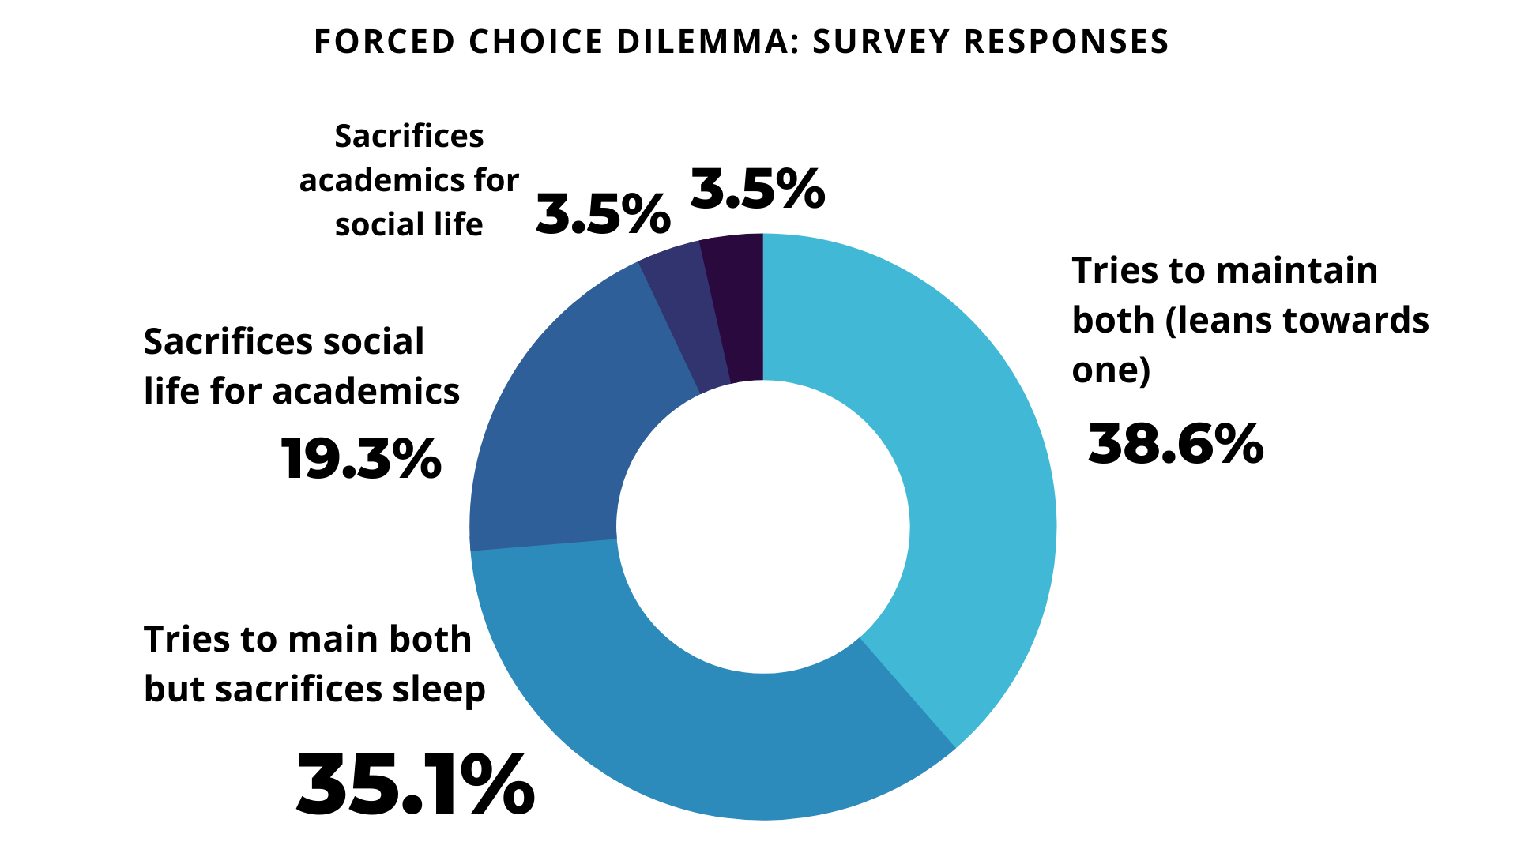

Lack of sleepwas prominent within both data collection methods as shown in **Figure 4** and **Figure 5**. Segments within the chart depict the categories students acknowledged to sacrifice to attain academic achievement or a social life. This strengthens the existing agreement amongst the majority of participants indicating that they felt the need to turn away from their personal enjoyments or one aspect of their life in order to succeed in the courses they were taking. 35.1% of survey participants reported that in order to maintain both, they sacrificed sleep. The presence of sleep deprivation in multiple tests hint towards it being a primary consequence of the rigors of accelerated course load.

Aligned with the researcher’s predictions, most participants responded that they had experienced discrepancies on their mental health, noting major differences between their transition from junior high to high school. Testing the prominence of discrepancies on students’ mental health, shown in **Figure 6**, the most notable reported factors were sleep deprivation, burnout, and anxiety. Each factor being present in more than 50% of participant reports. Additionally, 70.6% had reported problems with excessive stress.

**Figure 6: Frequencies within Students’ Mental Health Impacts**

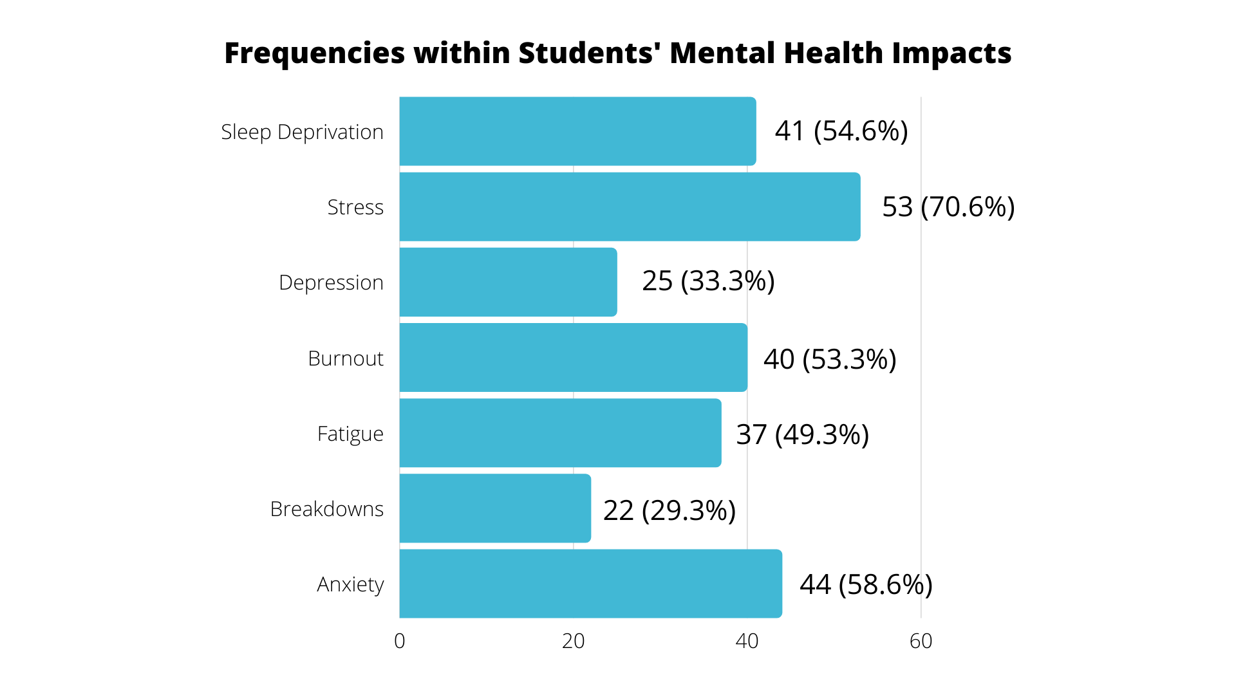

In terms of the prominence of discrepancies on students’ academic functioning, students noted that their academic struggles were attributed to heavy workloads, additional activities, and busy work (50%) whilst 70.2% reported problems with their attention span as noted in **Figure 7**.

**Figure 7: Frequencies within Students’ Academic Functioning**

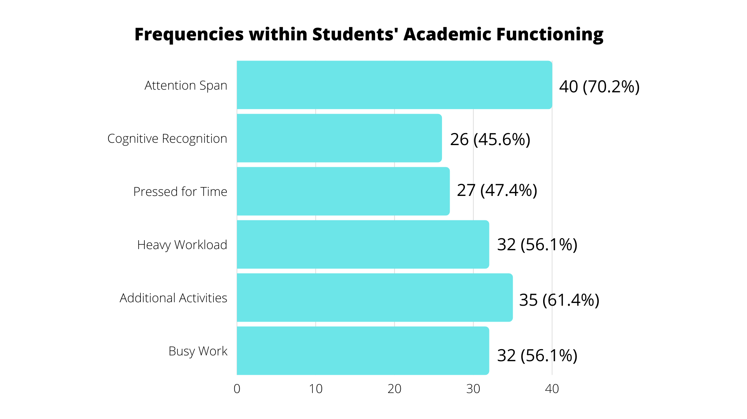

The prominence of specific factors of mental health and academic function raise questions towards the approach of AP courses. With the frequency of stress and anxiety amongst other impacted cognitive functioning The participants noted that they disagreed with the layout of the AP courses taken each year, disliking the restrictions which put a cap on the number of AP’s allowed within a specific grade level and being unable to take certain AP courses earlier than allowed in the framing system. This opened up to a predicted discussion regarding next steps towards formatting AP courses and their requirements. Corresponding to the researcher’s belief, both sets of participants did not strongly urge for a speed change in learning course material; however, instead focused on wanting AP course diversity and facilitation of concepts that fit reasonably within an average teenagers’ schedule outside of school hours. Participants expressed their acknowledgement of AP courses and the requirement for accelerated learning, but wanted to make changes towards the approach of facilitating the course materials: utilizing time in class to teach the course material (47.4%), homework meant to facilitate learned skills in class and not for new concepts (50.9%), reduction of busy work assignments (52.6%), and flexibility with students’ schedules, assignment-wise (57.9%). This shows that AP requirements: number of AP courses, accelerated course learning, expectations, and AP exams – might not be entirely correlating with students’ mental health and academic performance. Rather, AP requirements and their approach towards facilitating learning material could possibly be representing a more causational relationship that is adding onto students’ deteriorating mental health.

**Limitations**

Despite the prominence of certain factors, 75 participants do not encompass the entirety of the rigorous small-learning community nor the rest of the school’s population that had undergone their own experiences within AP courses. The insufficient sample size cannot stand as a stead-fast conclusion, yet it can depict this small populations’ mindset and general experience that can later be expanded on through further research on a larger scale to see whether said certain factors were prominent within a larger population. In terms of the data collection method, wording of questions could have implied bias. Multiple choice questions already had preset options which could influence the participants’ choices; no extra thoughts would be required to answer the question. Within the surveys, participants were asked various questions which were attributed to evaluating specific aspects of their life: mentally, physically, socially. From the Perceived Stress Evaluation to the Self-Efficacy Evaluation, the question phrasing remained neutral and there was little to no option to input bias in the answers as the multiple choice questions ranged from either how often the participant experienced the event or how much they agree with the provided statement. However, the personal experience portion of the survey leaned towards conveying a neutral tone. To compensate for this, the researcher added an “other” option on questions to allow additional thoughts. A similar aspect could be found in the interview portion as certain questions could have been read with connotations which could have implied a certain feeling towards the interviewed subject. The question phrasing could potentially influence the responder and tear them away from the previous perceived answer to the question and report back an answer the researcher wants based on the wording of the question. At most, for that group of individuals, a similar mindset could be discovered which could later sit as proof behind possible correlations between AP requirements and mental health impacts. Taking time constraints into consideration, attributed due to unavailability of possible interview participants within school hours; the majority of the underclassmen did not have an off-period in the morning, leaving the only times for interviews to be at lunch or after school. For interviews, primarily male participants, there stands a possibility that responses did not reflect full honesty. Participants may not have been comfortable sharing what they truly experienced to a stranger, causing data to appear more neutral than what it actually was.

**Conclusion**

The original hypothesis stated that the more AP courses students’ took, the higher the presence of negative factors of mental health and academic performance deterioration. This study showed that assumption was half correct. The majority of the results revealed that with an increased load of AP course requirements, upperclassmen experienced higher levels of perceived stress and moderate self-efficacy (functioning) and chose to sacrifice personal enjoyment in order to focus on their responsibilities. Individuals pursuing accelerated curriculum learning did experience various impacts on their mental health from their involvement in AP programs, sleep deprivation being a prominent factor; however, their involvement did not necessarily correlate with a deteriorating academic performance. Despite the impact on their mental health, 77.8% of participants reported minimal impact on their academic performance. They chose to sacrifice their mental health to achieve academic success. “A small price to pay for a greater reward of academic achievement,” according to 60% of participants. In the end, 94.6% of participants indicated that while not necessarily heavily impacting their academics score-wise – attributed to their developed mindset and goals – the structure of AP teaching approaches made participating in their small-learning community more stressful and demanding than it should have been.

**Future Implications**

With attention to reform directed towards AP teaching approaches, this information could shift the basis of future research, focusing on the way AP curriculum is taught and facilitated rather than just focusing on students’ cognitive and physical functioning within the programs. These results do not produce definitive results due to smaller sample size collection, but further provide a general understanding of what is being experienced within the student body and can be formatted to restructure the teaching approaches to prevent negative student exhibition of mental health issues and any cases that impact academic performance. Teaching is a prevalent constant for advanced students pursuing AP curriculum courses. Teaching is meant to promote growth instead of decay. Understanding this subject would not only allow better showing academically (thereby making the programs look better), but also aid the individuals as they enter their respective colleges mentally sound. This research was not intended for programs to reduce content but instead to adjust the time spent towards teaching course material outside of school hours to allow for better engagement and functioning within designated class times. If changes like redrawing learning schedules to fit within class times and holding meetings amongst the teachers prior to the school year to discuss homework schedules to prevent overload and overlap are attempted, it would help to possibly reduce impact on students’ mental health and better prepare them for the transition into the college setting and work environment.

**References**

Benner, A. D. (2011). The transition to high school: Current knowledge, future directions. Educational Psychology Review, 23, 299-328. doi:10.1007/s10648-011-9152-0

Coleman, L. J., & Cross, T. L. (1988). Is being gifted a social handicap? *Journal for the Education of the Gifted, 11*, 41-56.

Foust, R. C., Hertberg-Davis, H., & Callahan, C. M. (2008). “Having it All” at Sleep's Expense: The Forced Choice of Participants in Advanced Placement Courses and International Baccalaureate Programs. *Roeper Review*, *30*(2), 121-129.

Foust, R. C., Hertberg-Davis, H., & Callahan, C. M. (2009). Students' Perceptions of the Social/Emotional Implications of Participation in Advanced Placement and International Baccalaureate Programs. Research Monograph Series. RM09238. *National Research Center on the Gifted and Talented*.

Howell, A. J., Jahrig, J. C., & Powell, R. A. (2004). Sleep quality, sleep propensity and academic performance. *Perceptual and motor skills*, *99*(2), 525-535.

Lazarus, R. S., & Folkman, S. (1984). Stress, appraisal, and coping. New York: Springer.

Patterson, J. M., & McCubbin, H. I. (1987). Adolescent coping style and behaviors: Conceptualization and measurement. Journal of Adolescence, 10, 163 – 186.

Shaunessy, E., Suldo, S. M., Hardesty, R. B., & Shaffer, E. J. (2006). School functioning and psychological well-being of international baccalaureate and general education students a preliminary examination. *Journal of Secondary Gifted Education*, *17*(2), 76-89

Shaunessy-Dedrick, E., Suldo, S. M., Roth, R. A., & Fefer, S. A. (2015). Students' perceptions of factors that contribute to risk and success in accelerated high school courses. *The High School Journal*, *98*(2), 109-137.

Subramani, C., & Kadhiravan, S. (2017). Academic stress and mental health among high school students. *Indian Journal of Applied Research*, *7*(5), 404-406.

Suldo, S. M., Shaunessy, E., & Hardesty, R. (2008). Relationships among stress, coping, and mental health in high-achieving high school students. *Psychology in the Schools*, *45*(4), 273–290. https://doi.org/10.1002/pits.20300

Suldo, S. M., Shaunessy, E., Thalji, A., Michalowski, J., & Shaffer, E. (2009). Sources of stress for students in high school college preparatory and general education programs: group differences and associations with adjustment. *Adolescence*, *44*(176).

Suldo, S. M., & Shaunessy-Dedrick, E. (2013). Changes in Stress and Psychological Adjustment During the Transition to High School Among Freshmen in an Accelerated Curriculum. *Journal of Advanced Academics*, *24*(3), 195–218. https://doi.org/10.1177/1932202X13496090

Suldo, S. M., Gormley, M. J., DuPaul, G. J., & Anderson-Butcher, D. (2014). The impact of school mental health on student and school-level academic outcomes: Current status of the research and future directions. *School Mental Health*, *6*(2), 84-98.

**Appendix**

**PURPOSE OF STUDY - Survey**

You are being asked to take part in a research study. Before you decide to participate in this study, it is important that you understand why the research is being done and what it will involve. Please read the following information carefully. Please ask the researcher if there is anything that is not clear or if you need more information.

The purpose of this study is to identify whether the requirements of rigorous college-level courses (AP) cause emotional impacts on a large urban high school students’ mental health and whether these requirements reflect on their academic success. By researching the implementation of these requirements and in what ways they are affecting students cognitive (ability to understand and comprehend) and performance abilities, this will help provide a better basis towards future research regarding the approach towards teaching the required course material WITHIN school hours and REDUCING the amount of time spent at home learning new concepts.

Informed Consent:

I have read and I understand the provided information and have had the opportunity to ask questions. I understand that my participation is voluntary and that I am free to withdraw at any time, without giving a reason and without cost. I understand that I will be given a copy of this consent form. I voluntarily agree to take part in this study.

_____ Yes _________ No

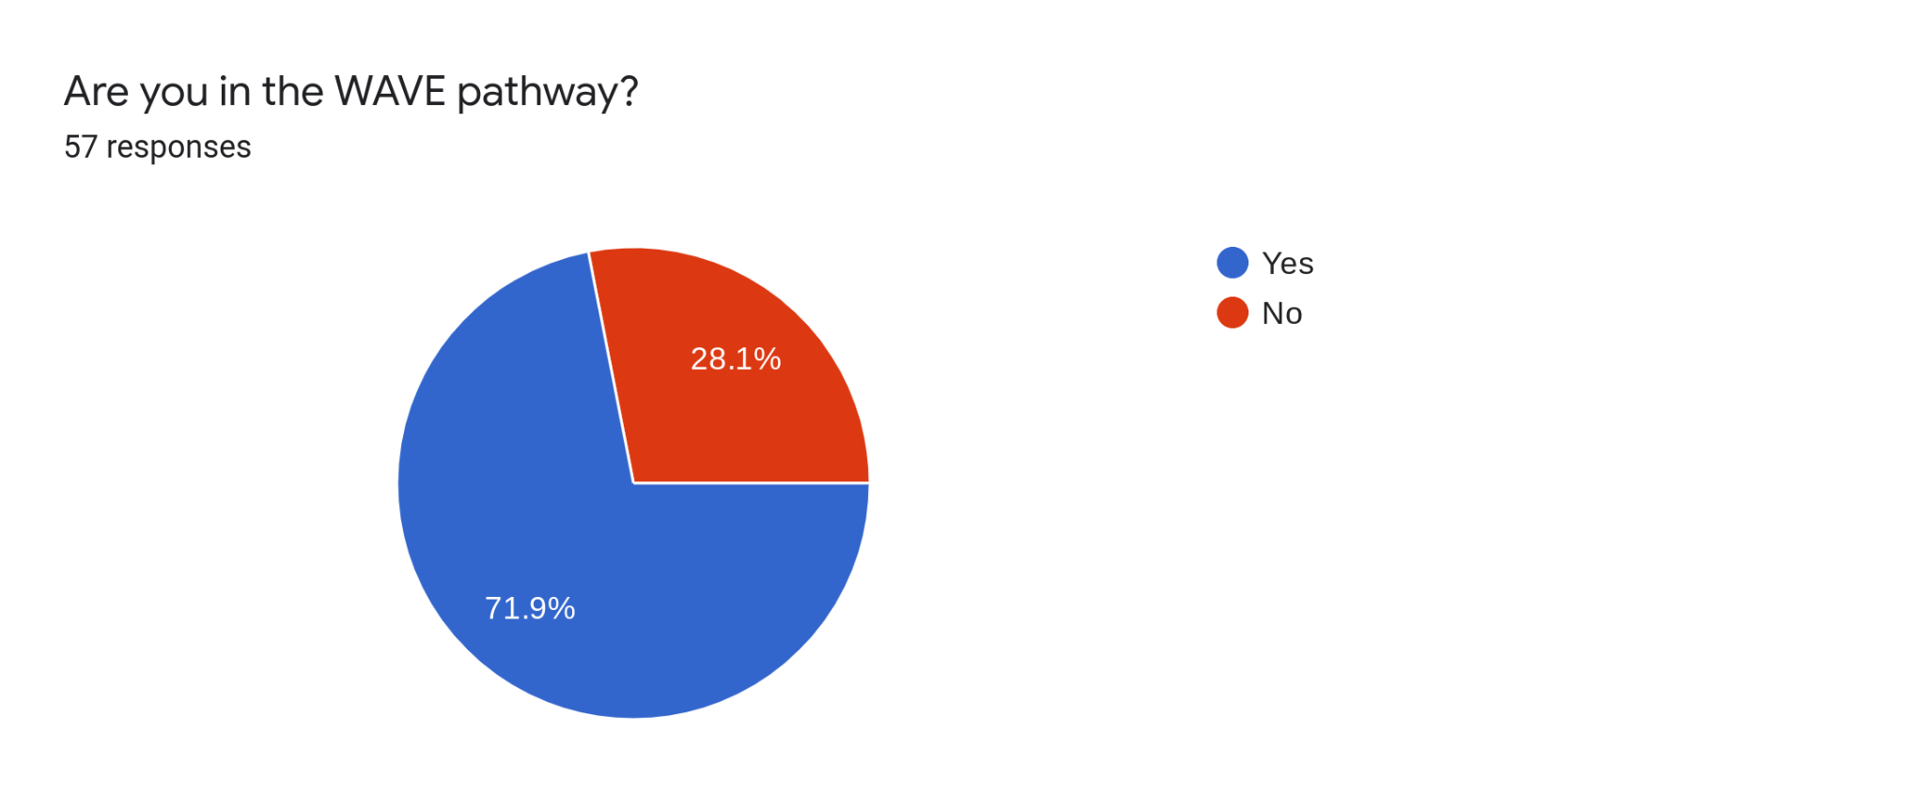

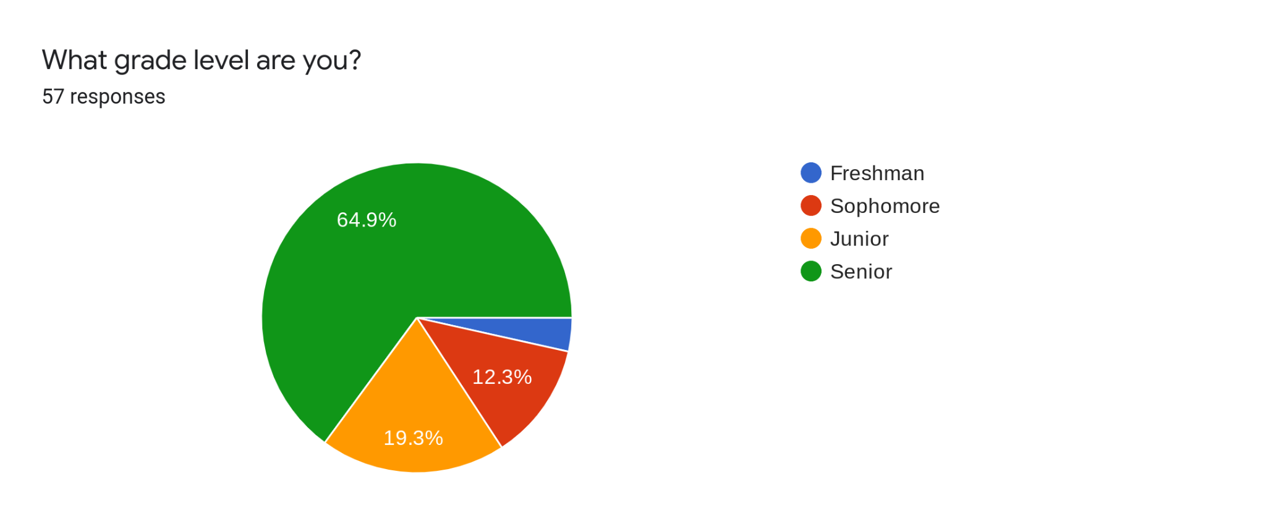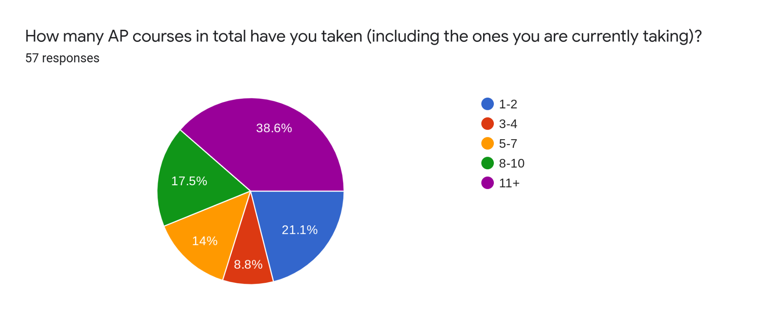

**Perceived Stress Level Rating Results:**

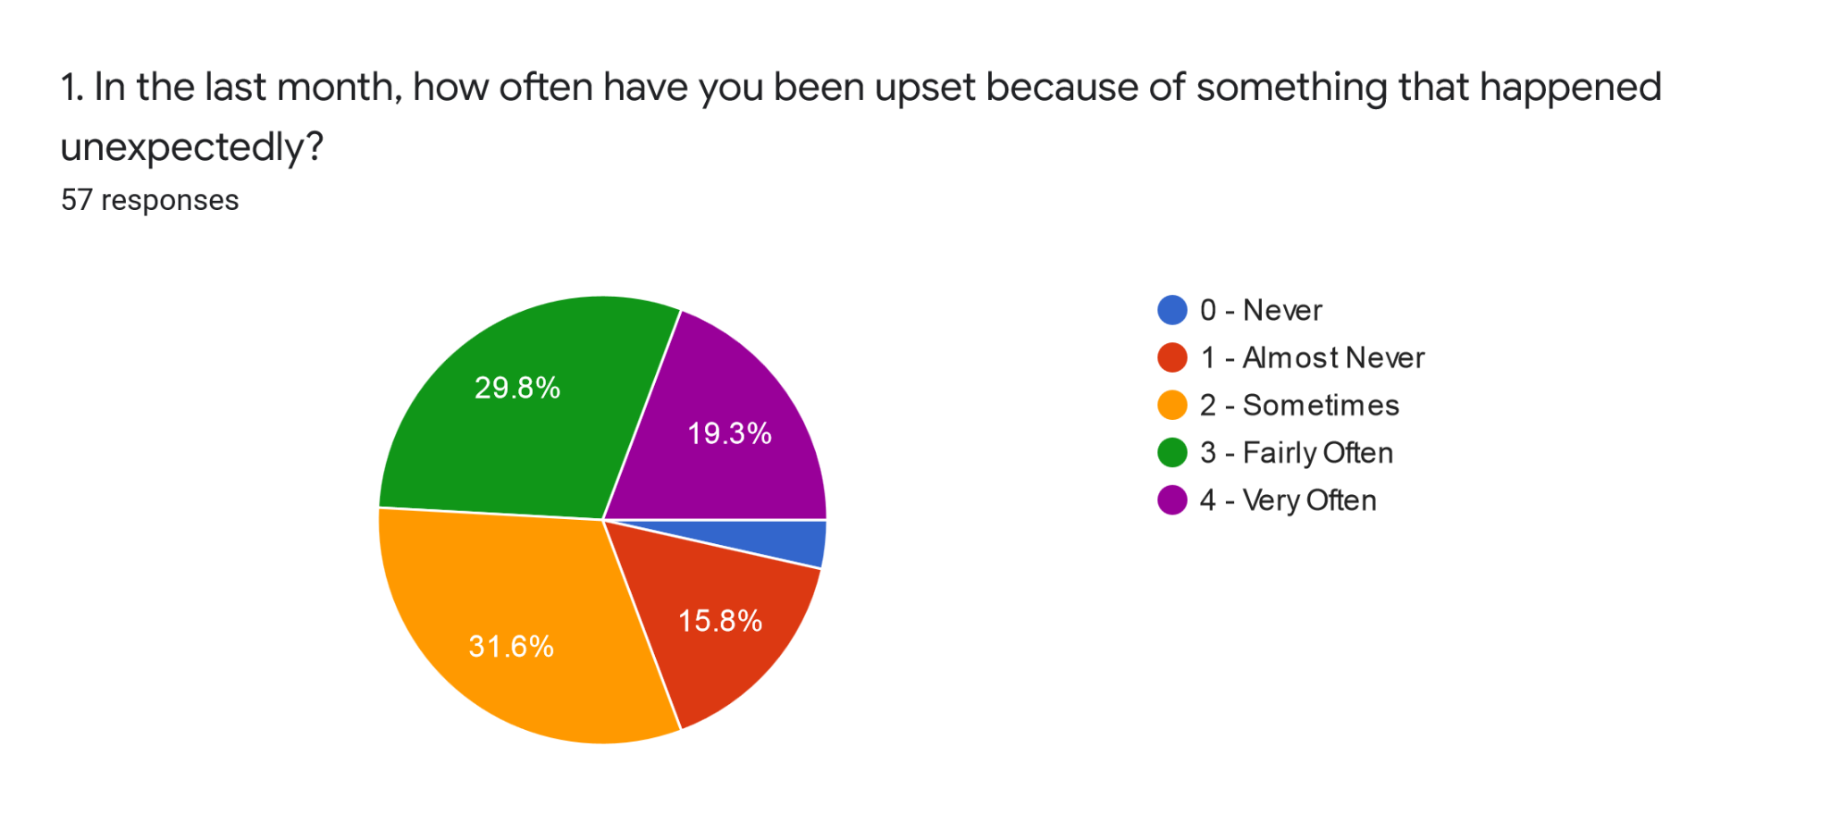

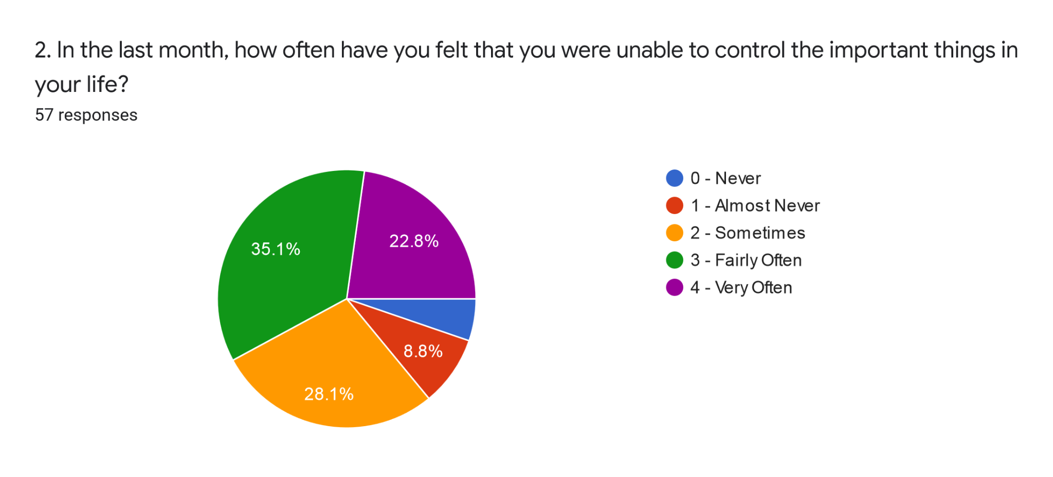

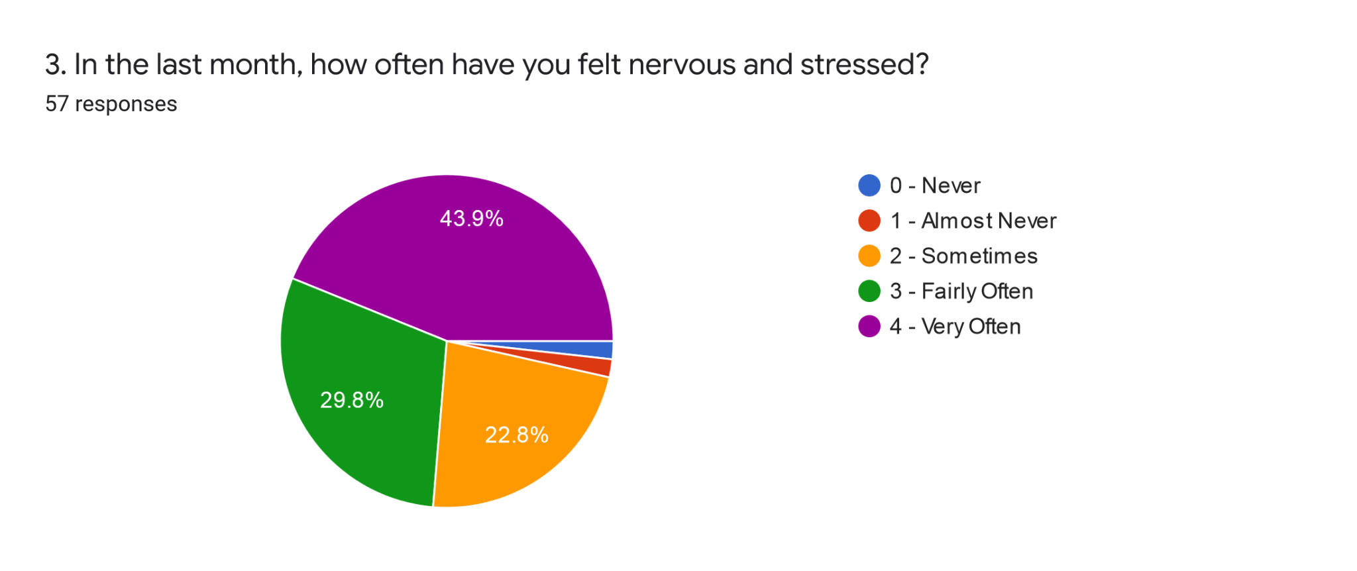

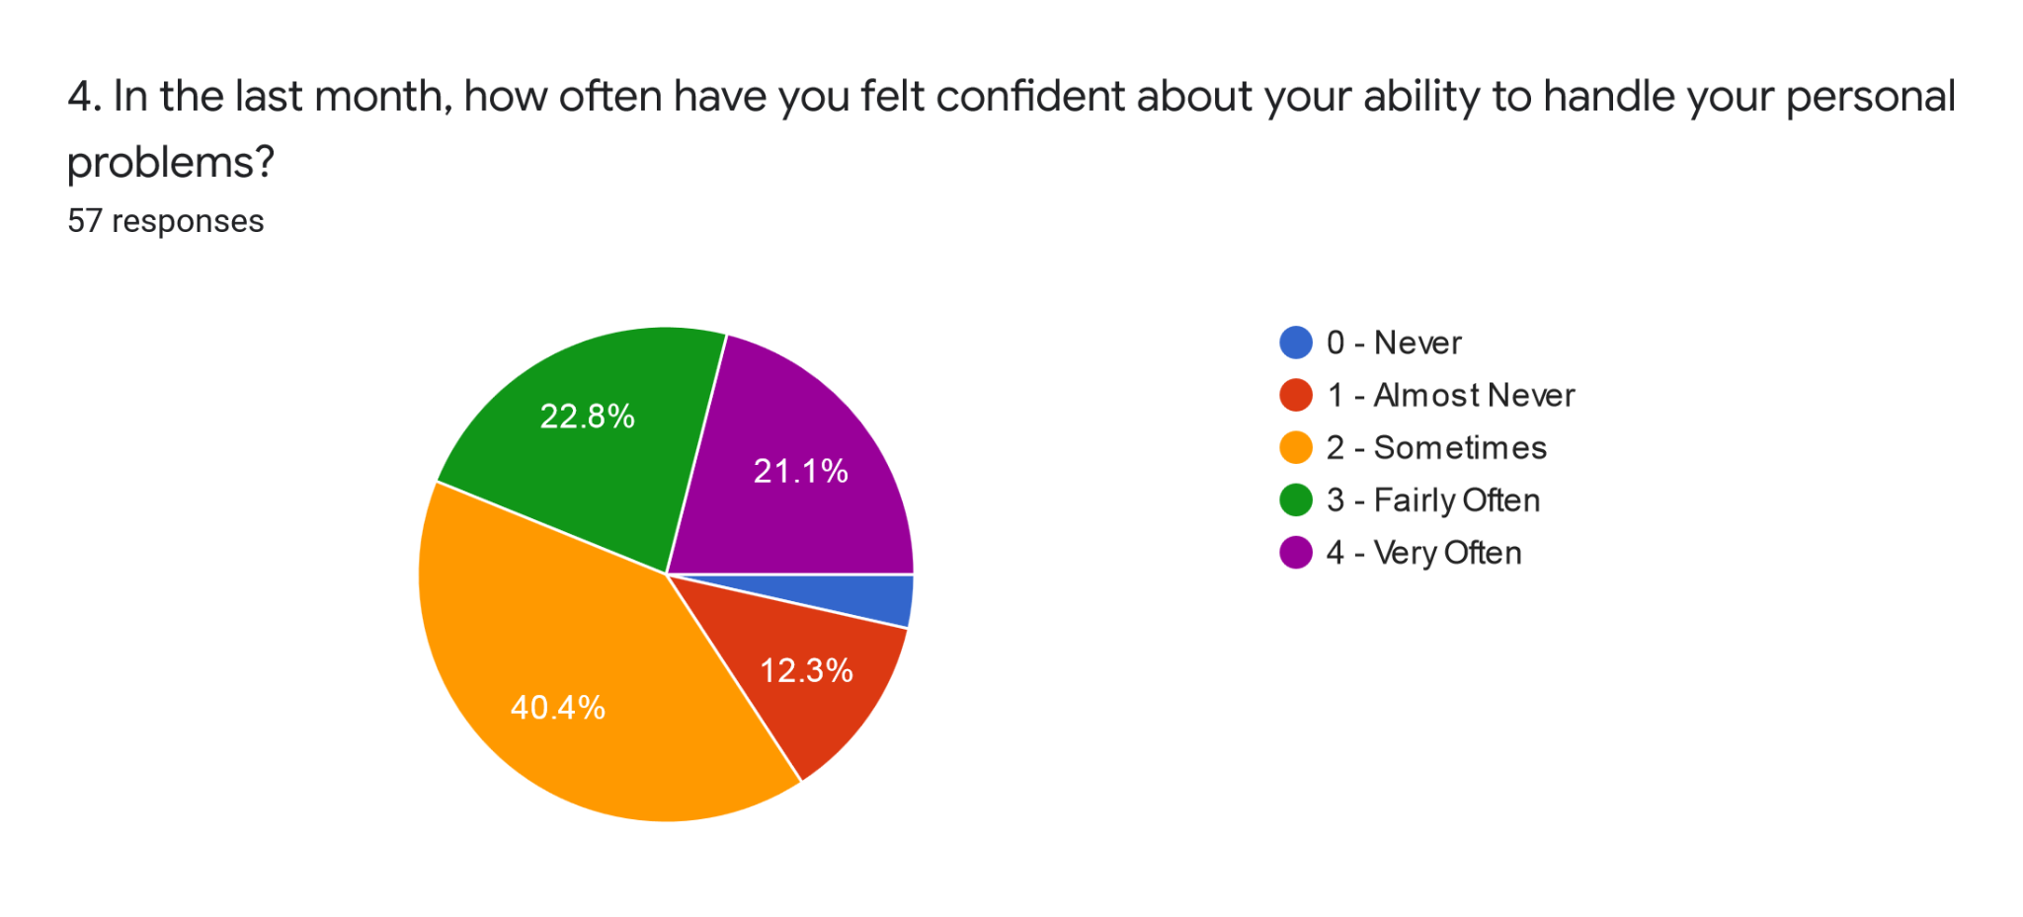

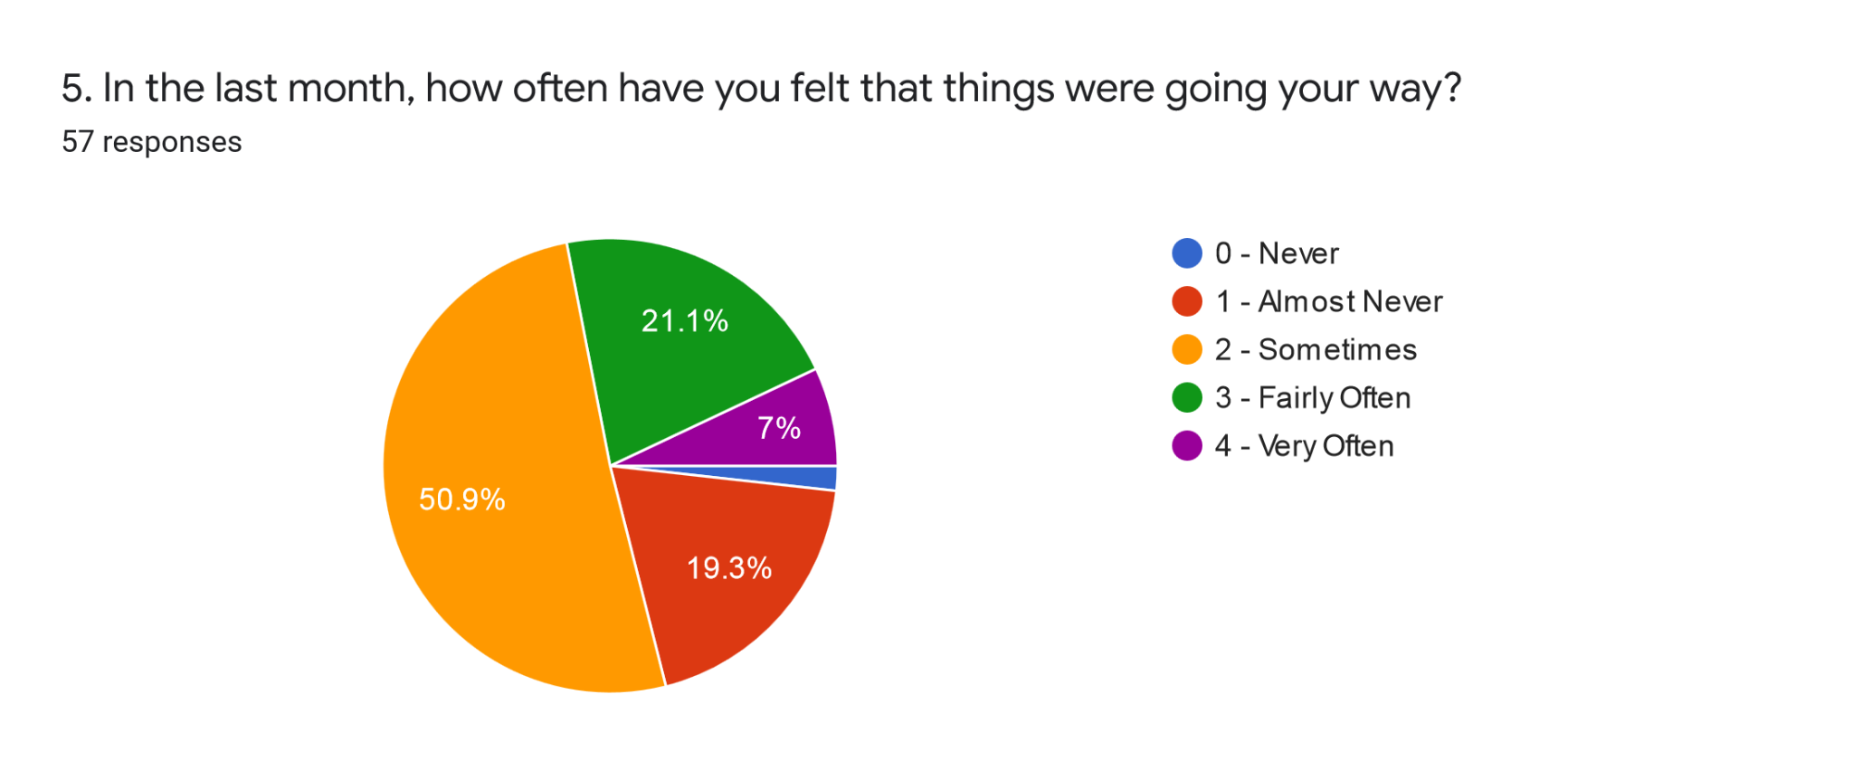

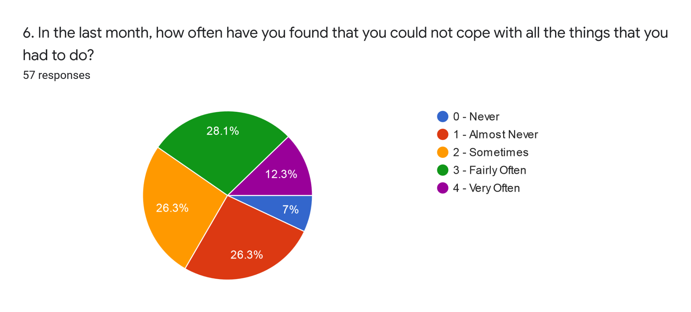

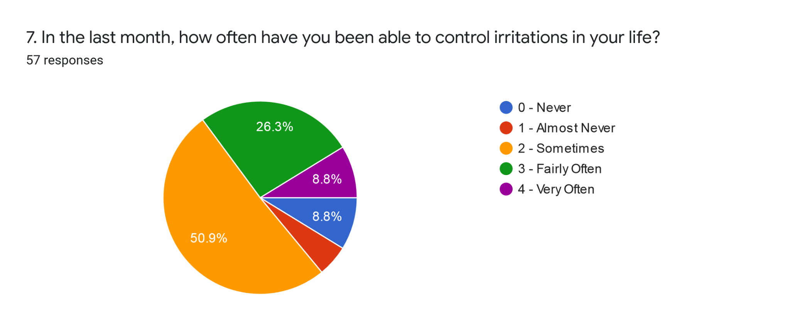

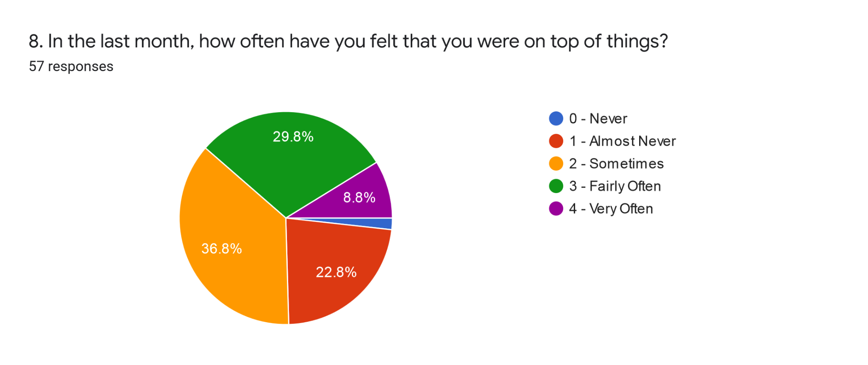

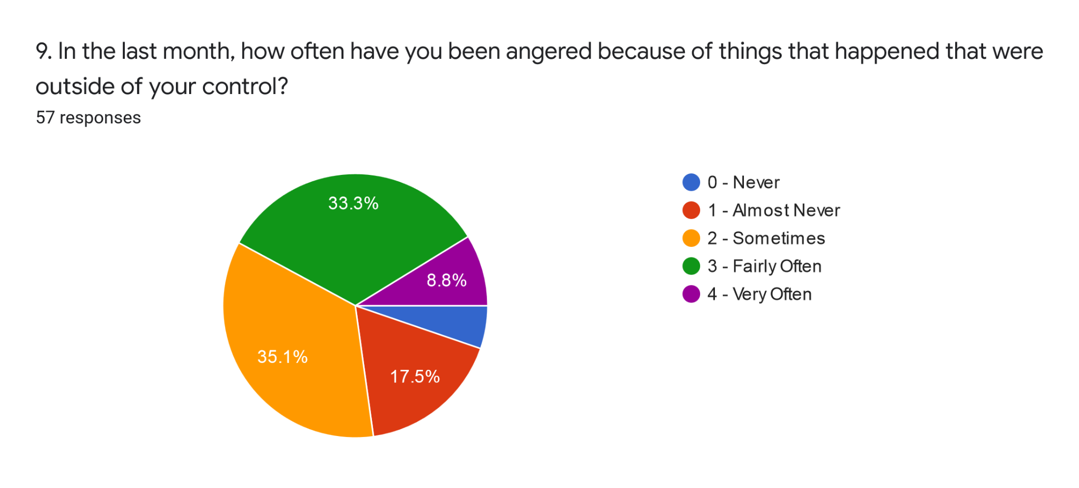

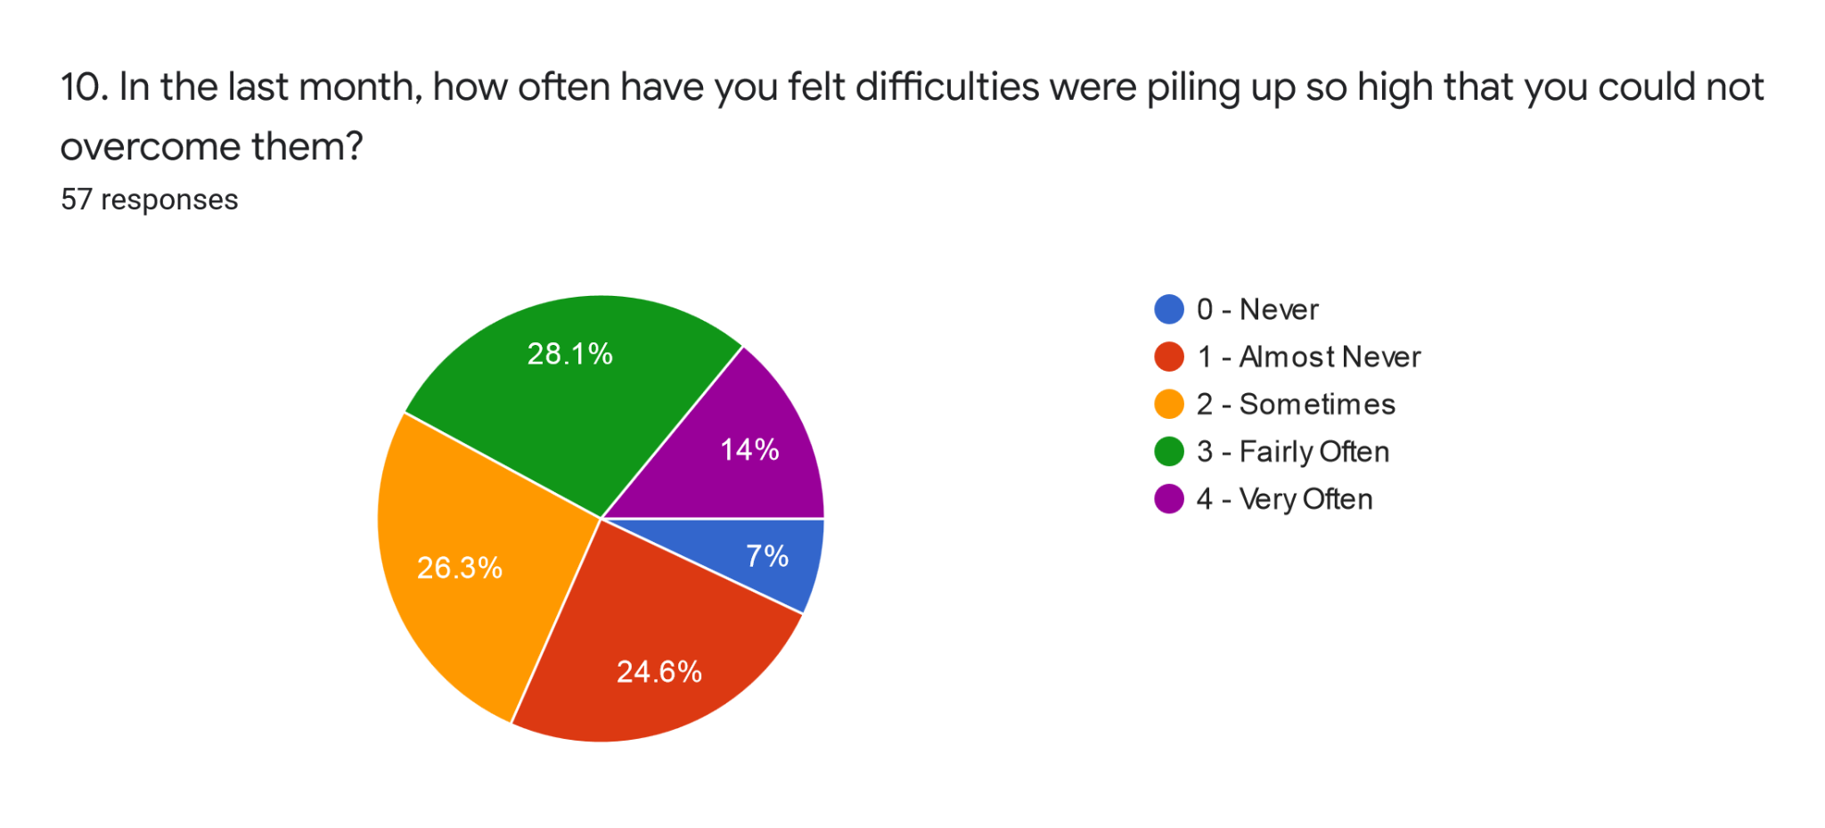

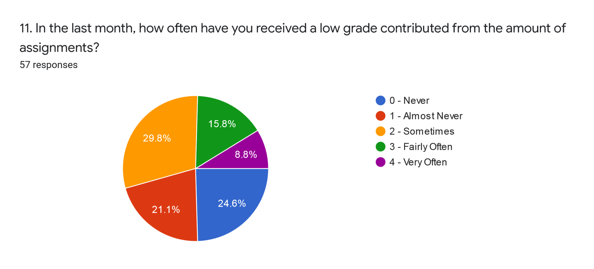

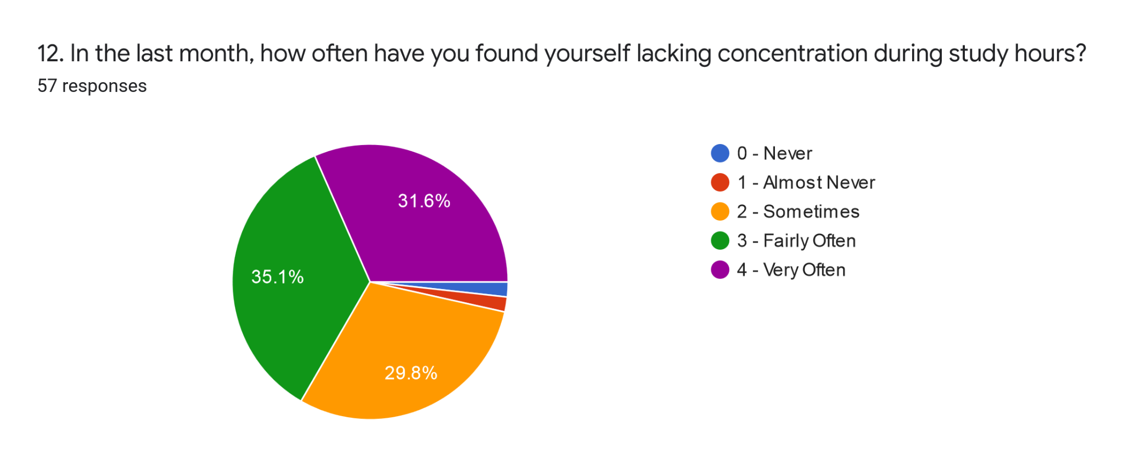

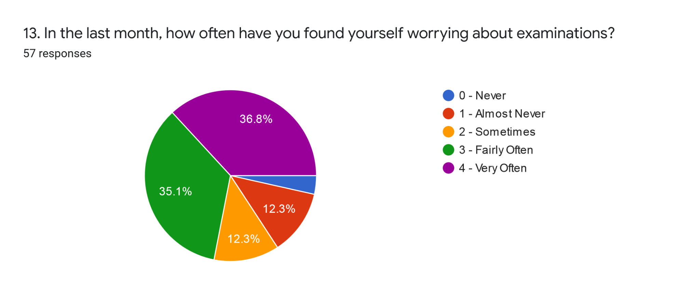

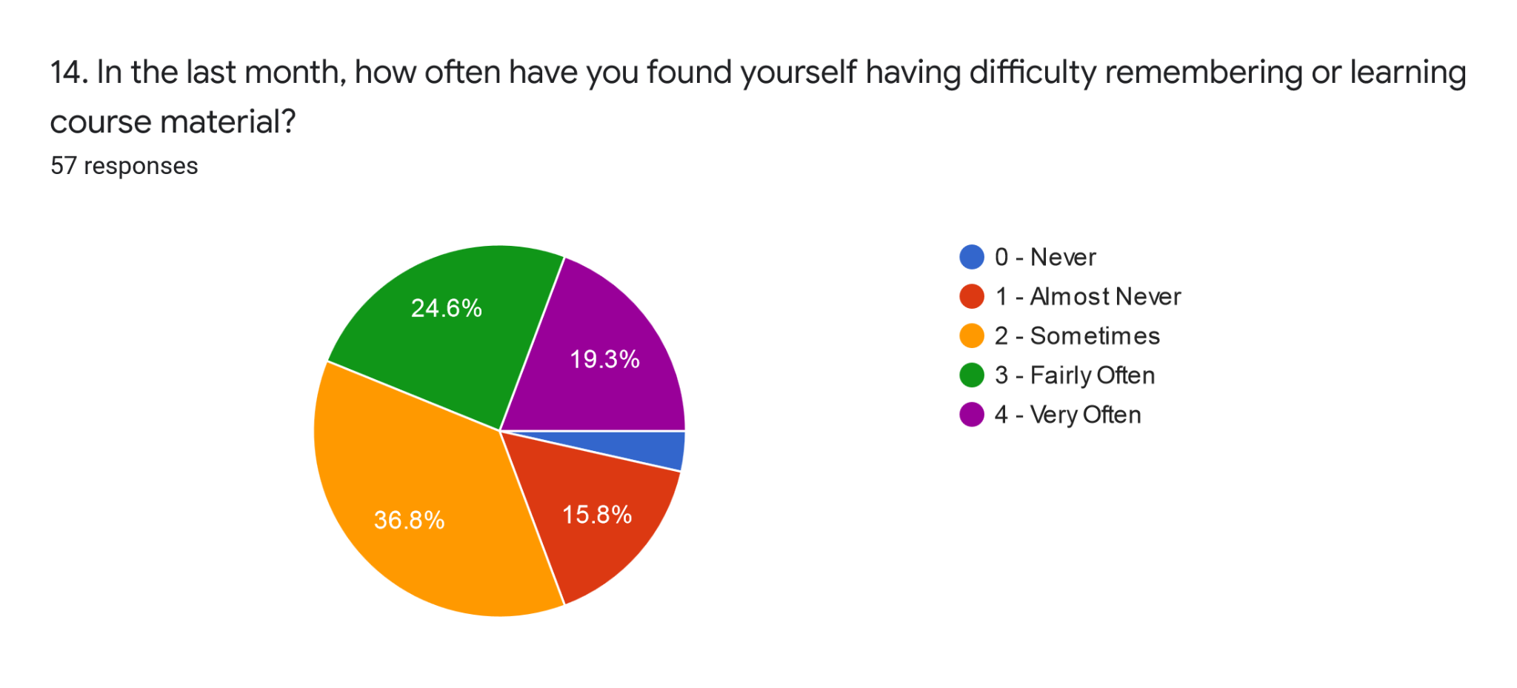

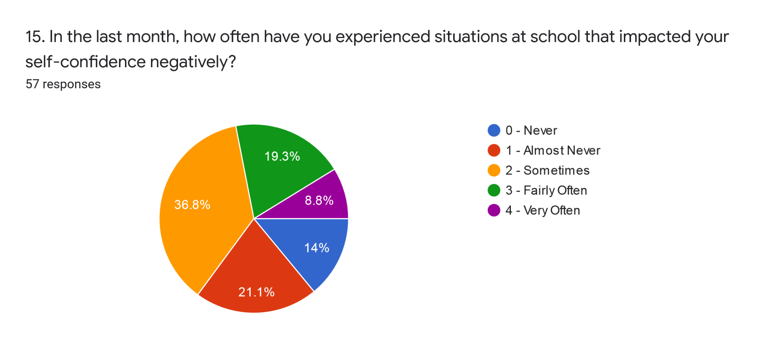

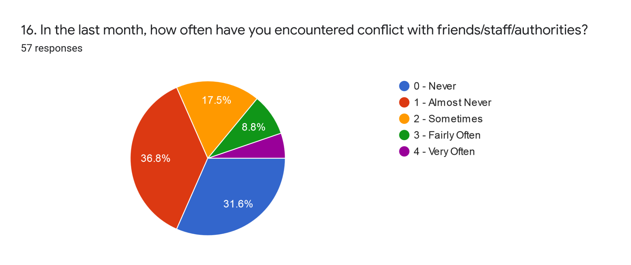

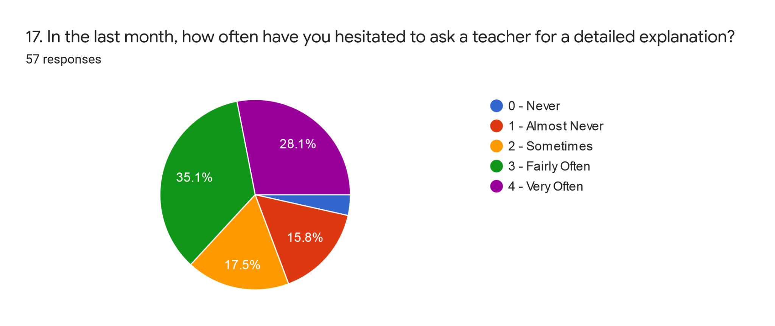

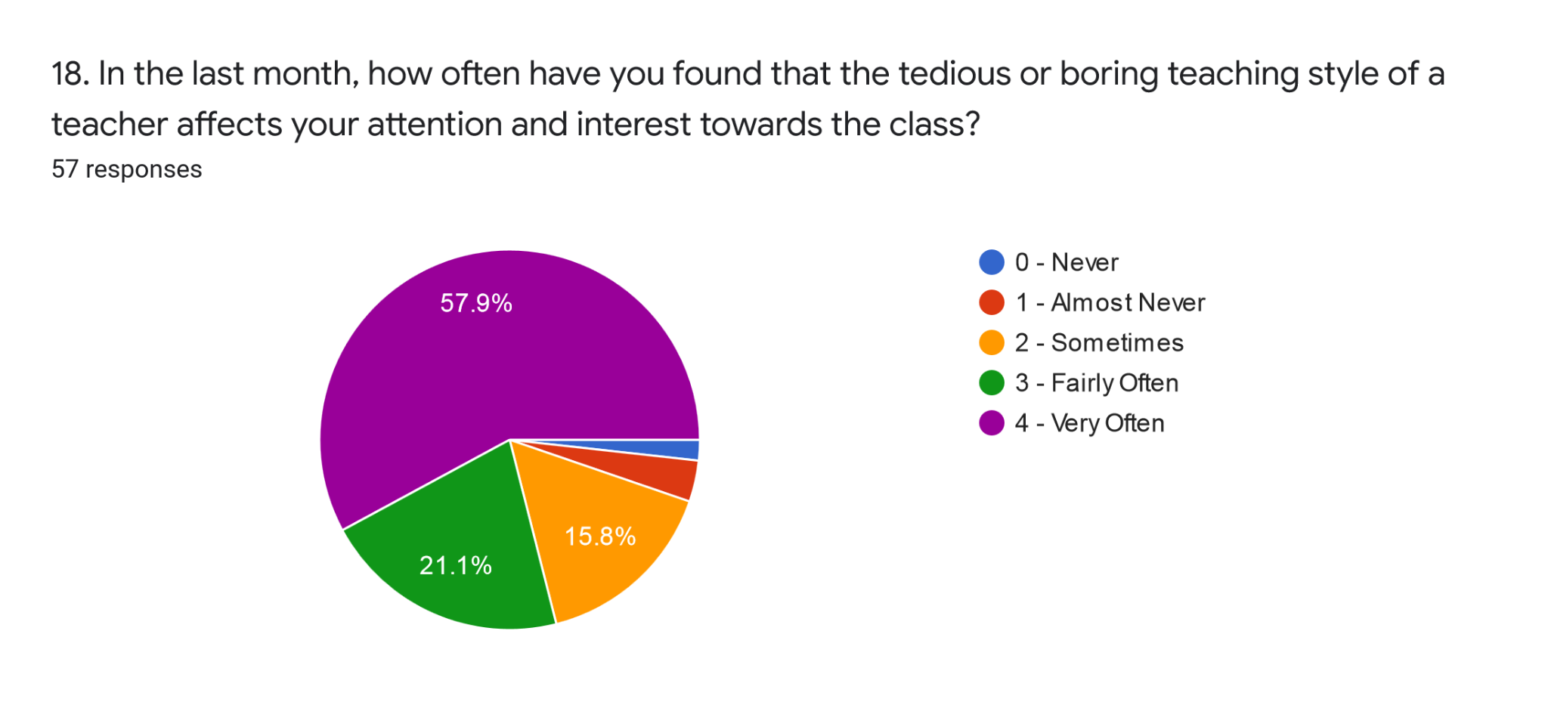

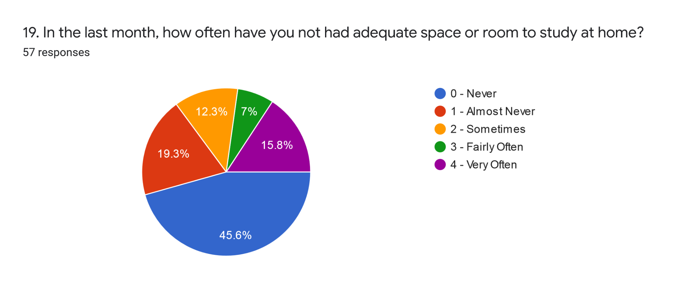

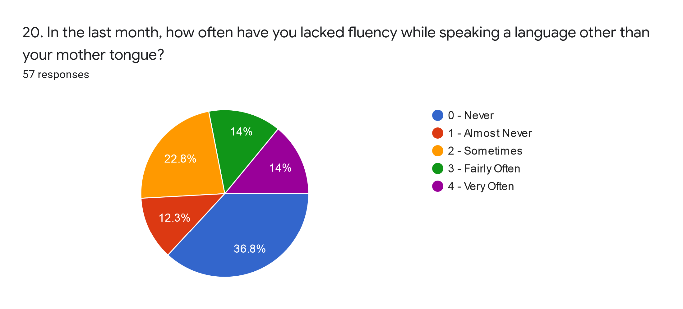

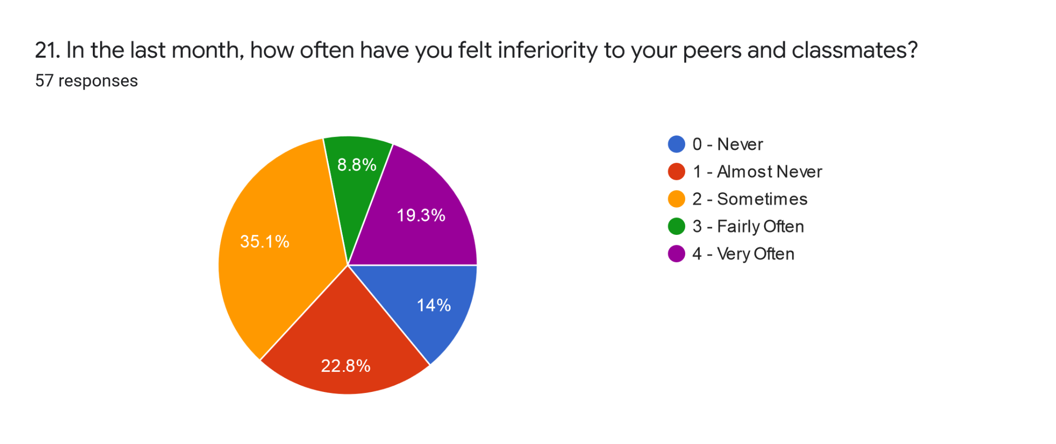

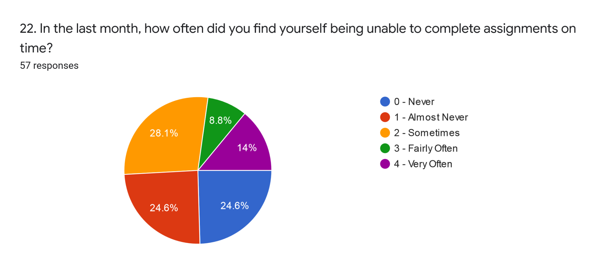

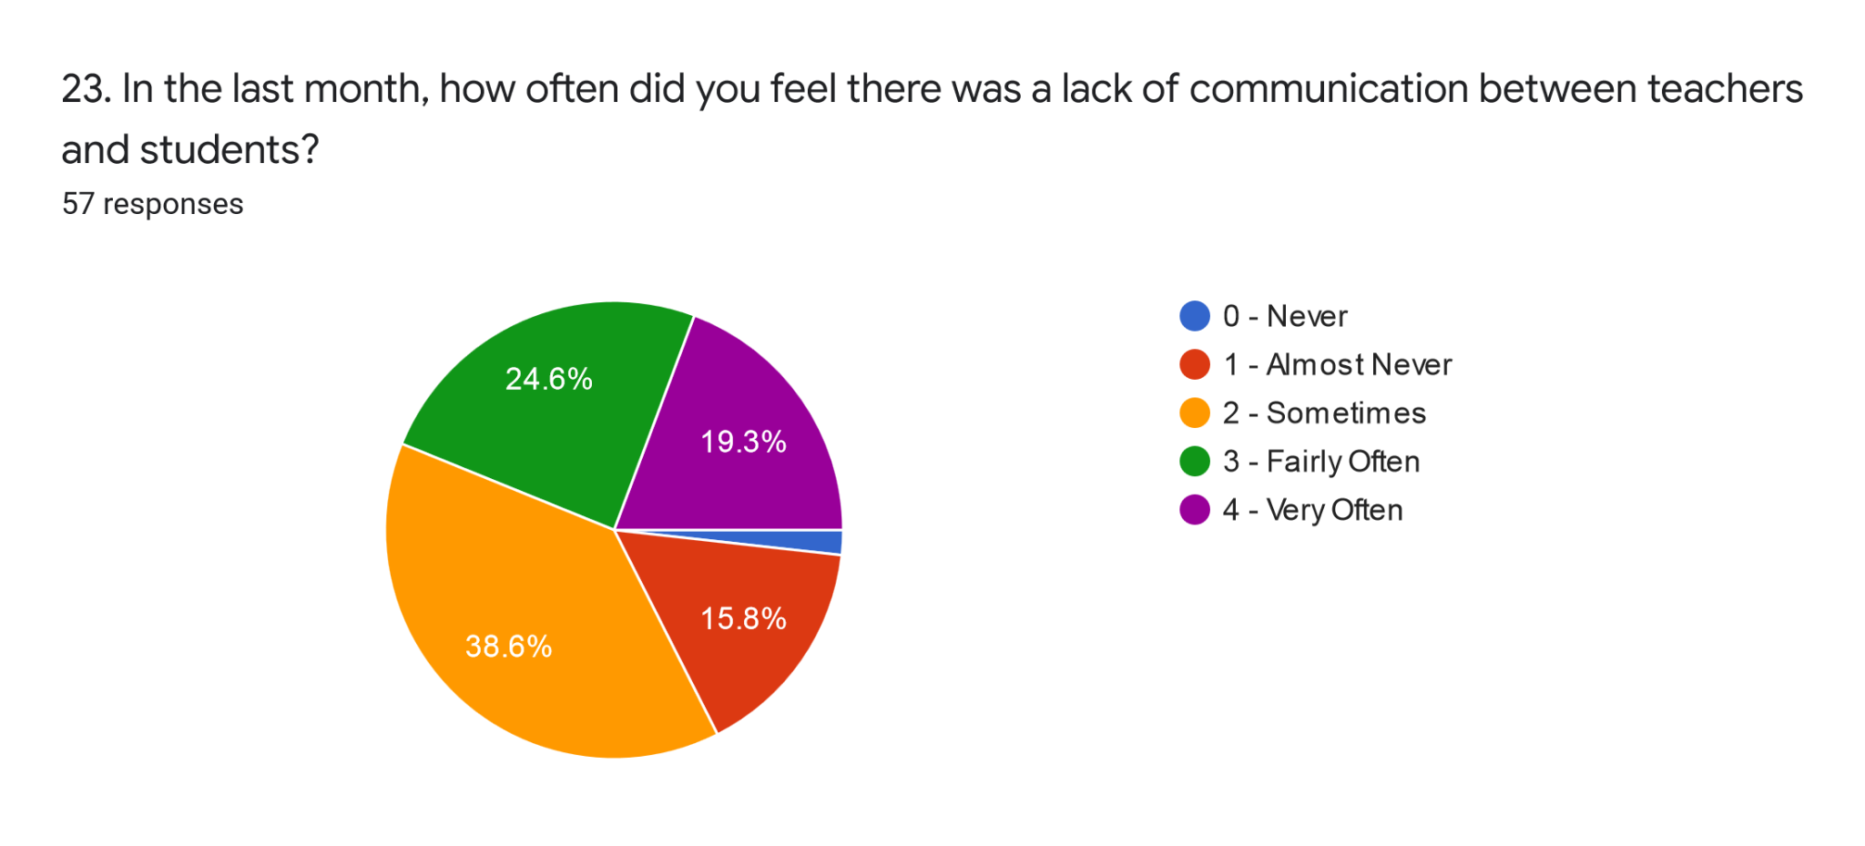

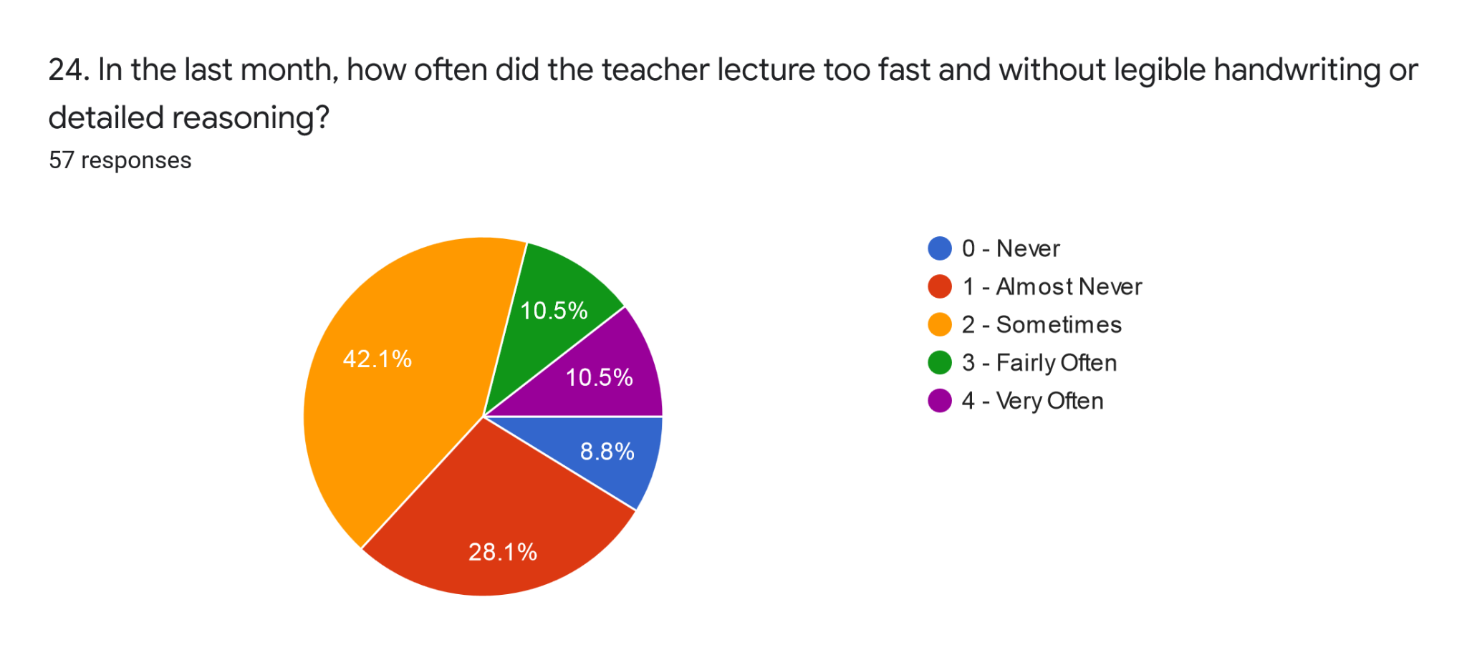

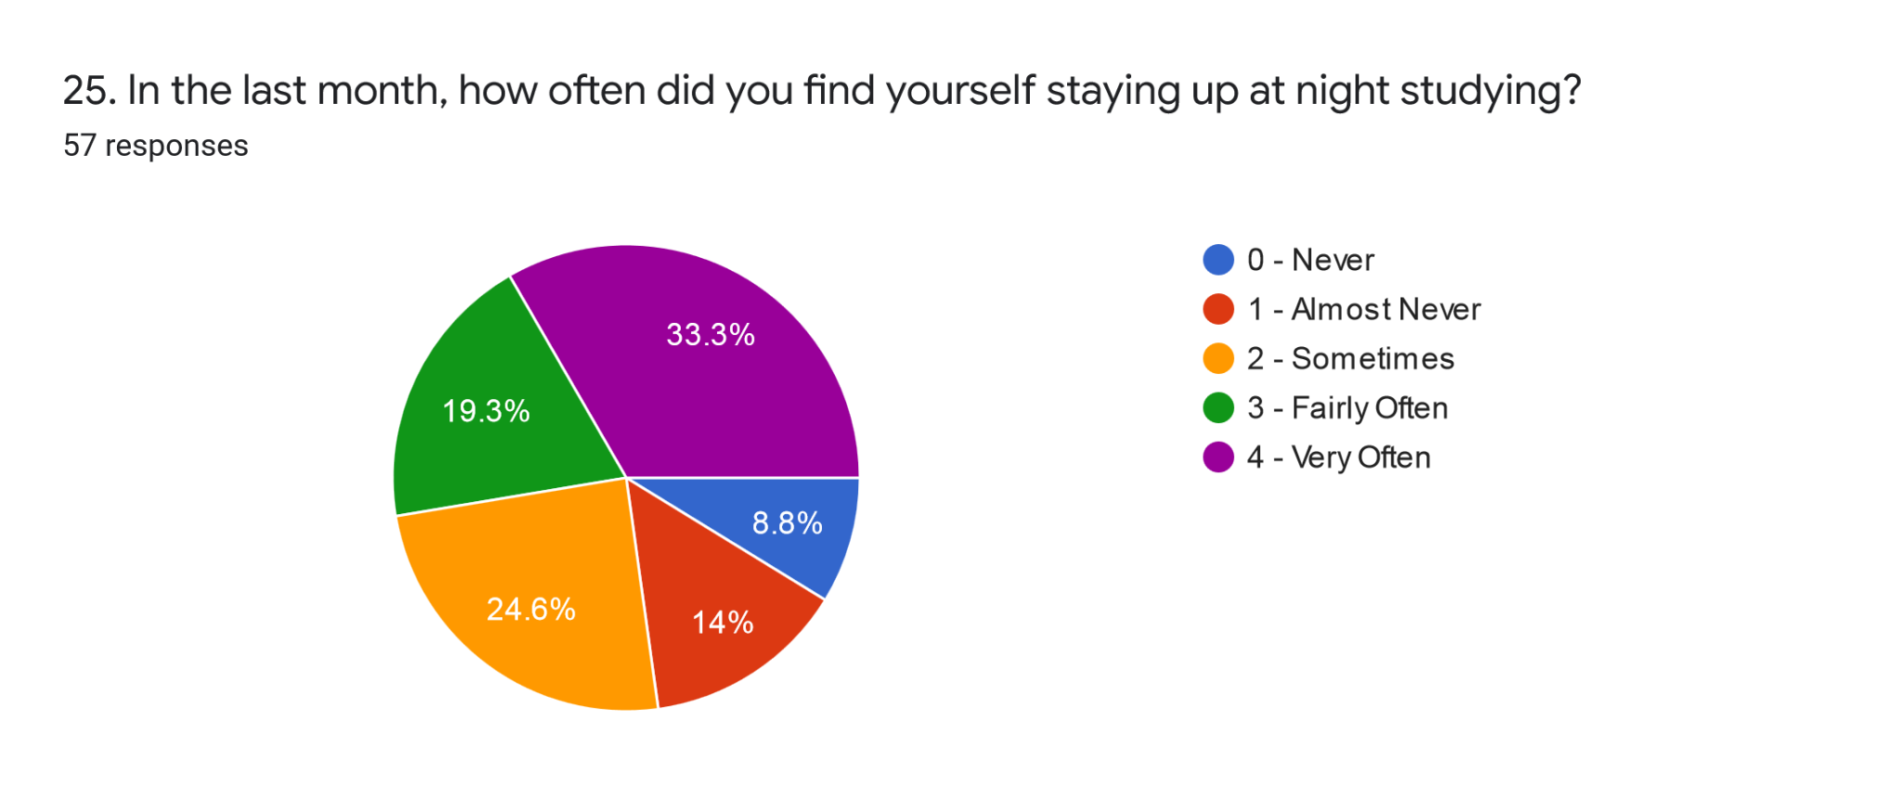

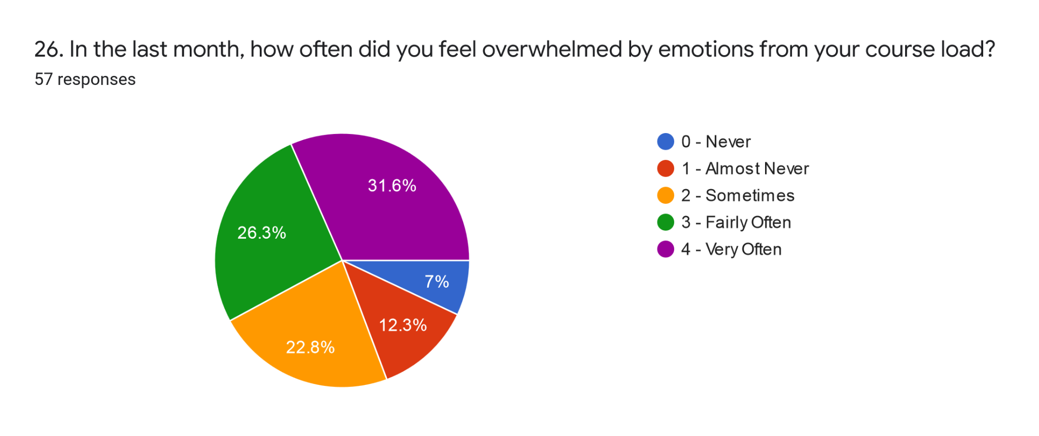

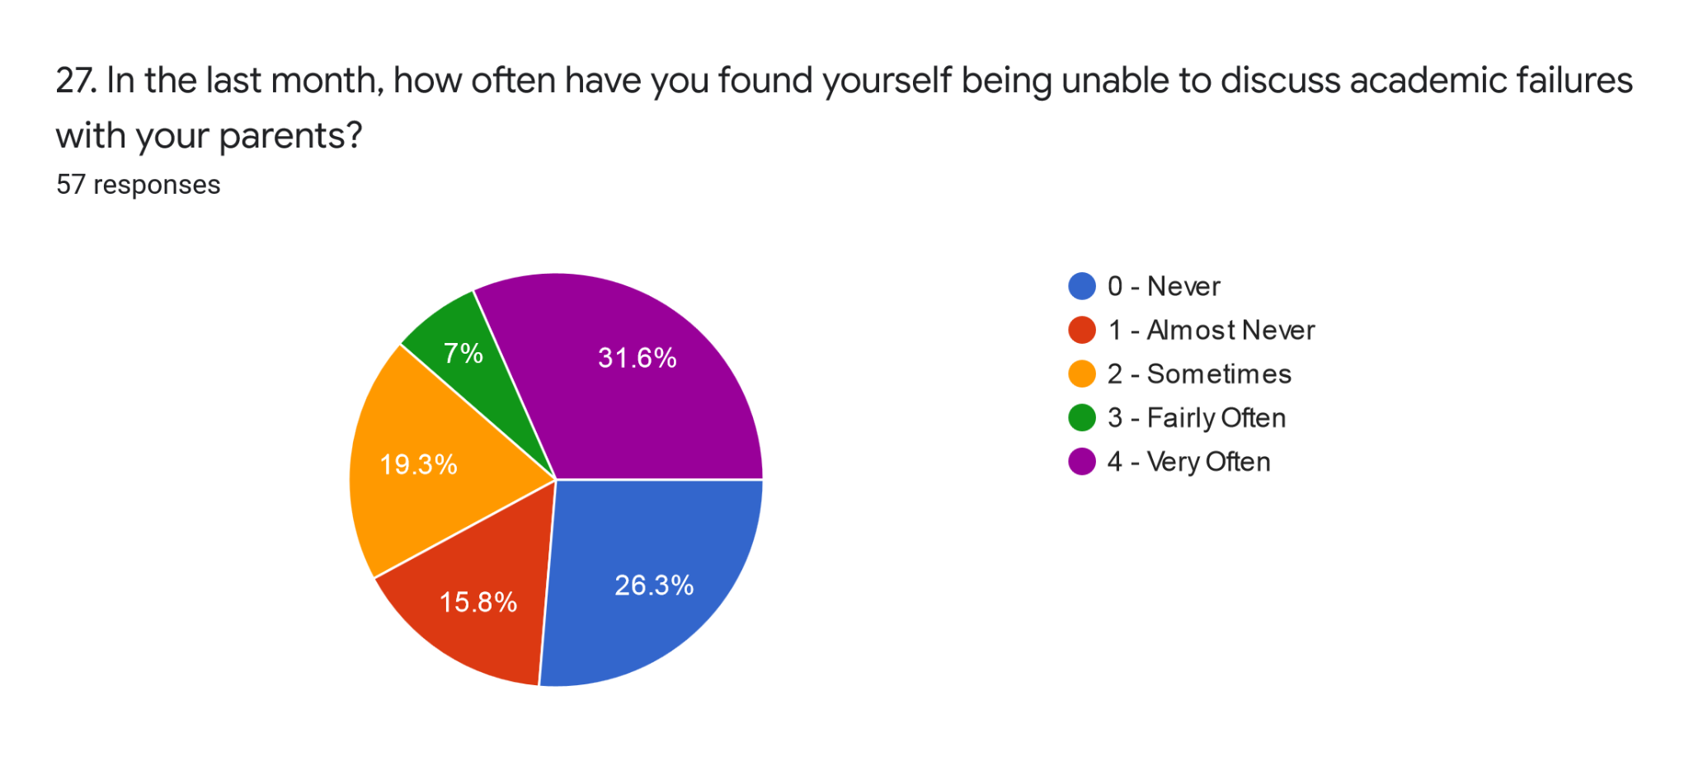

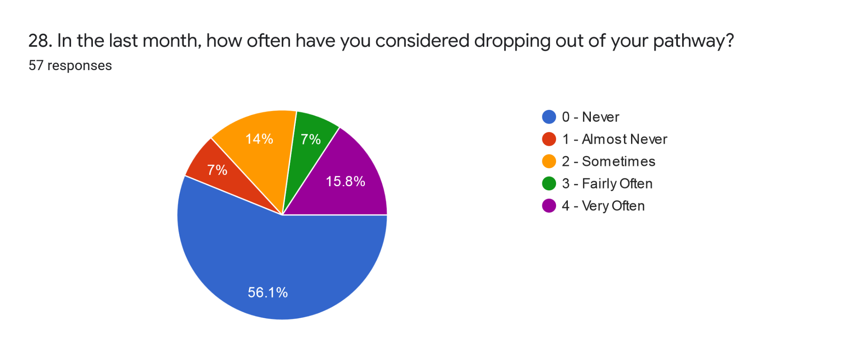

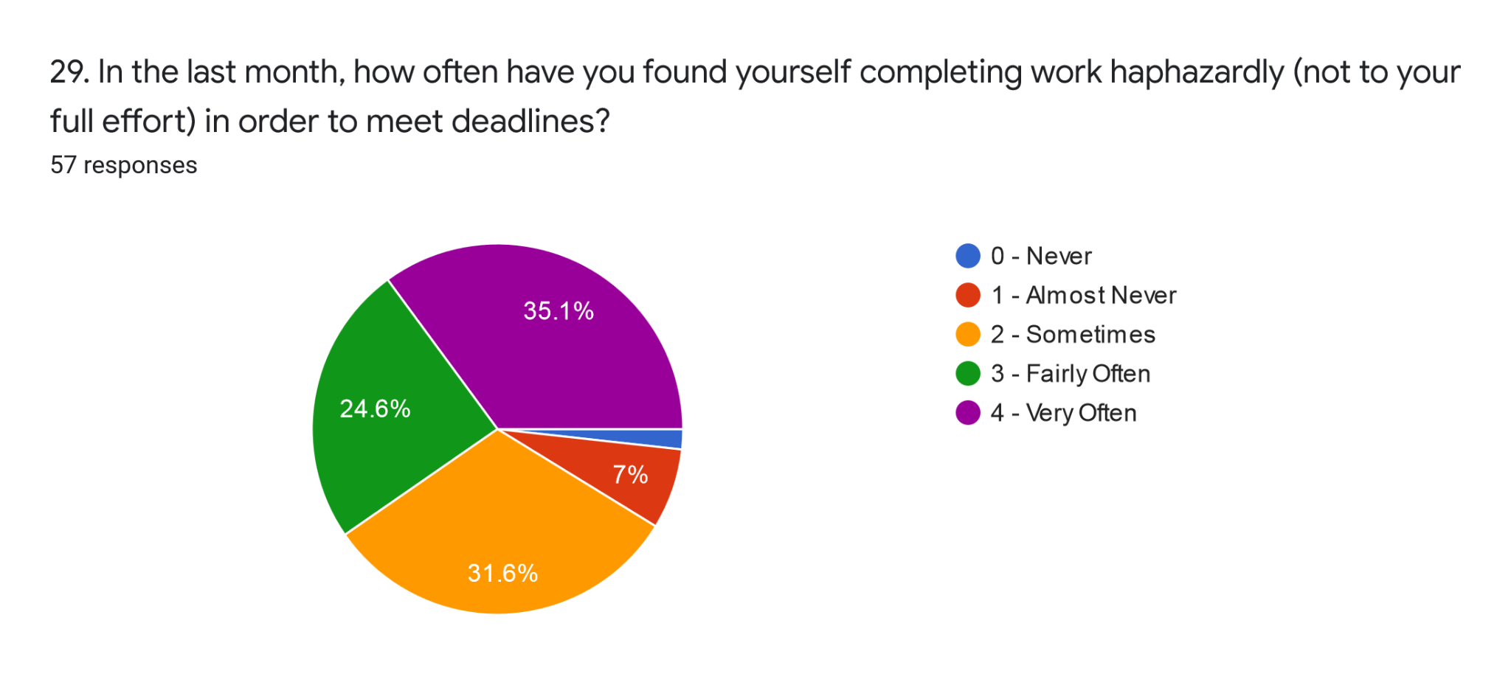

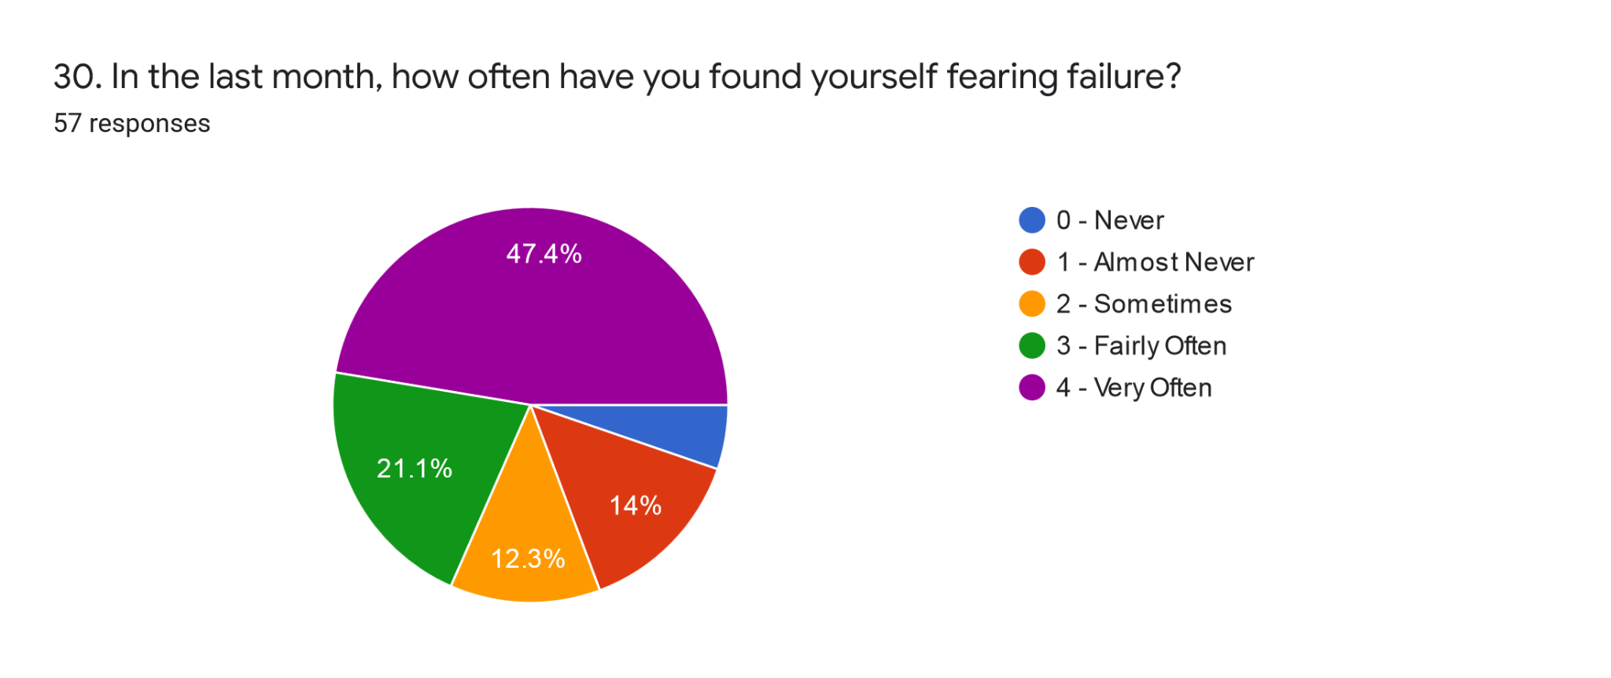

**Self-Efficacy Results:**

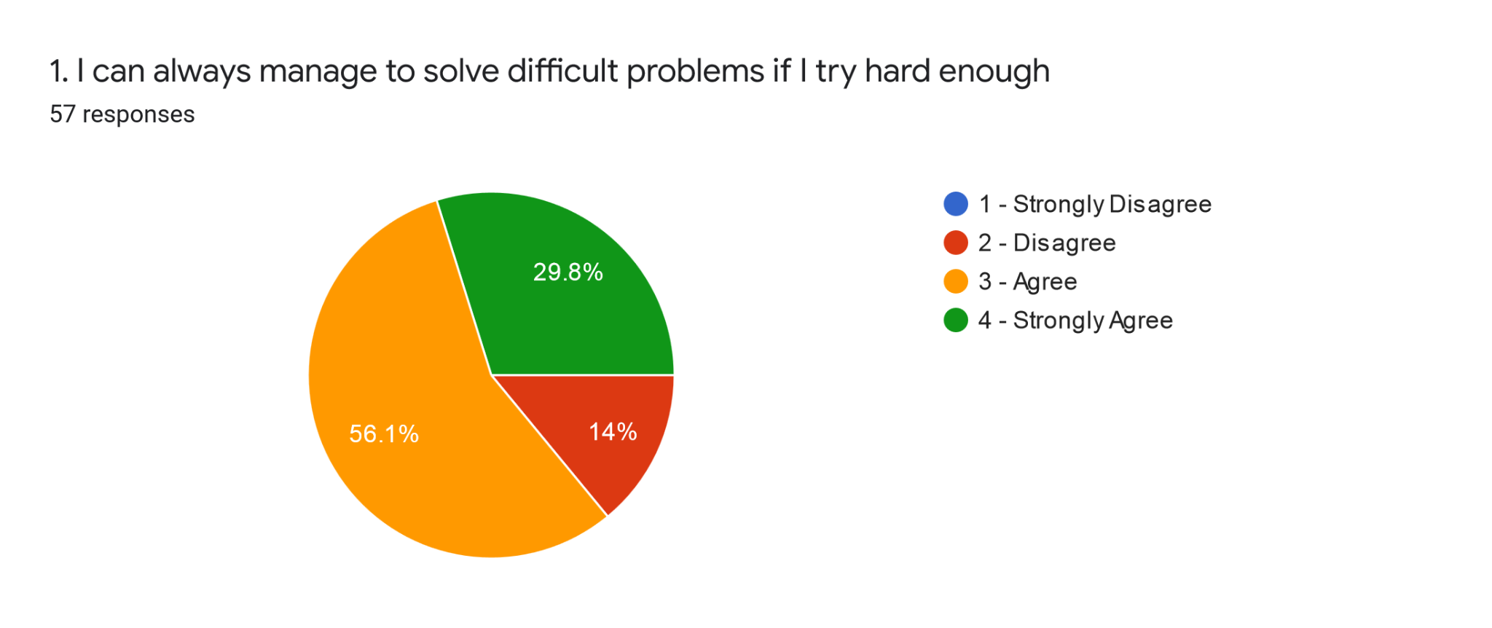

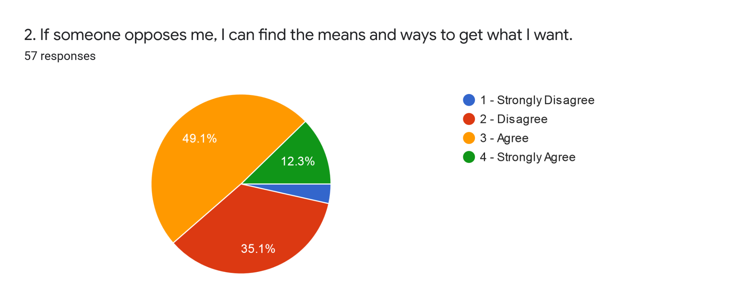

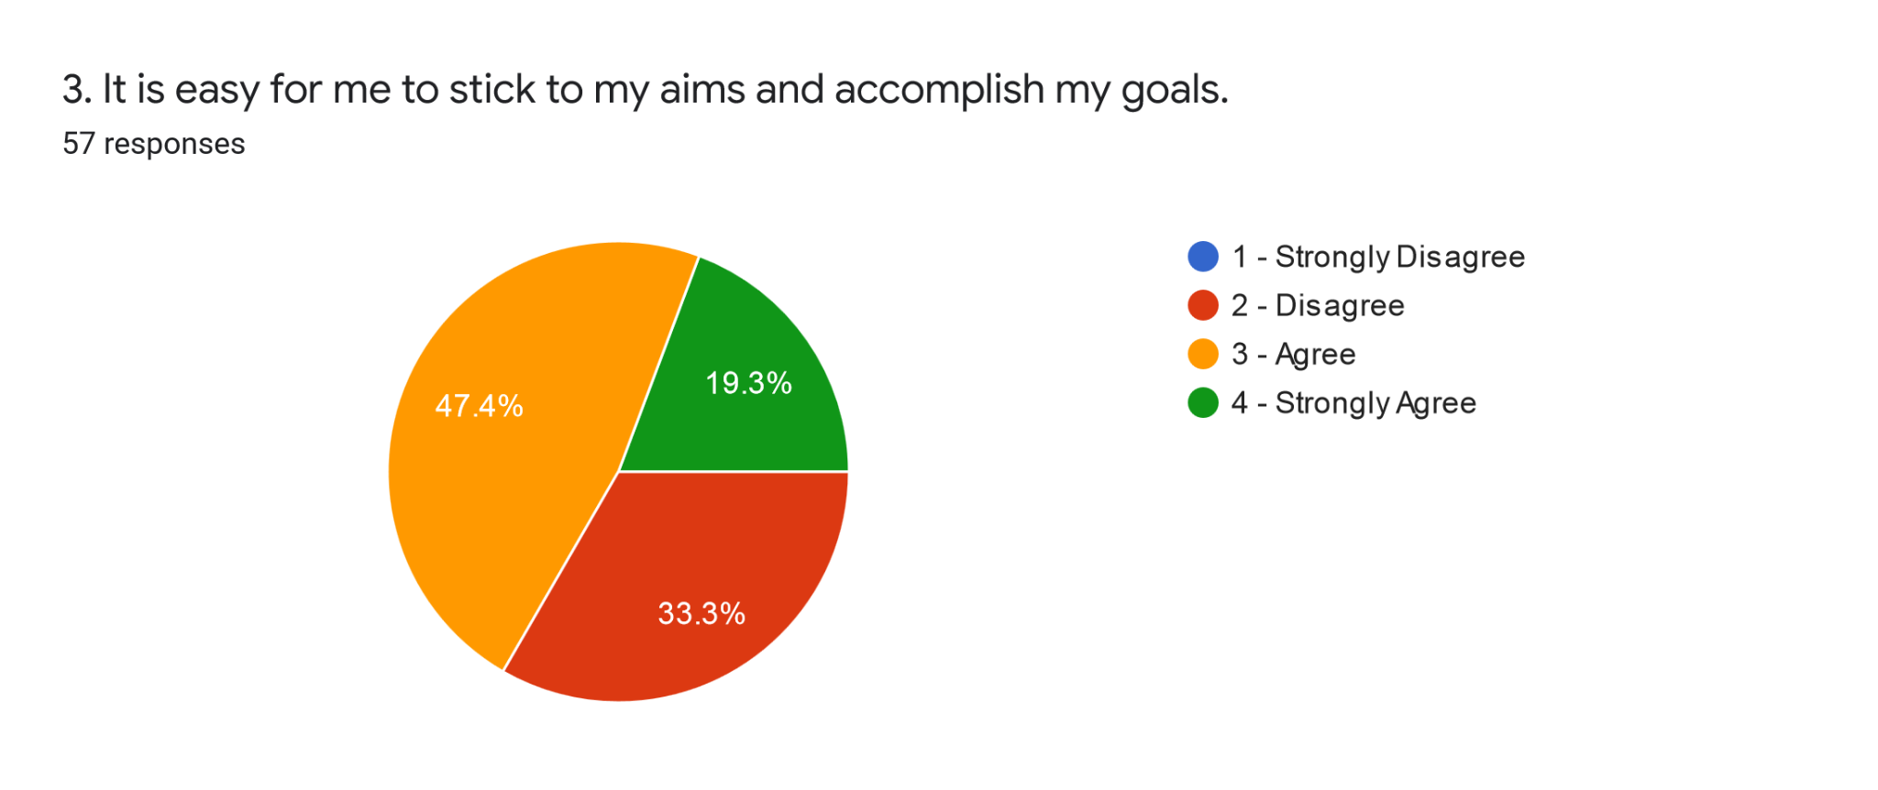

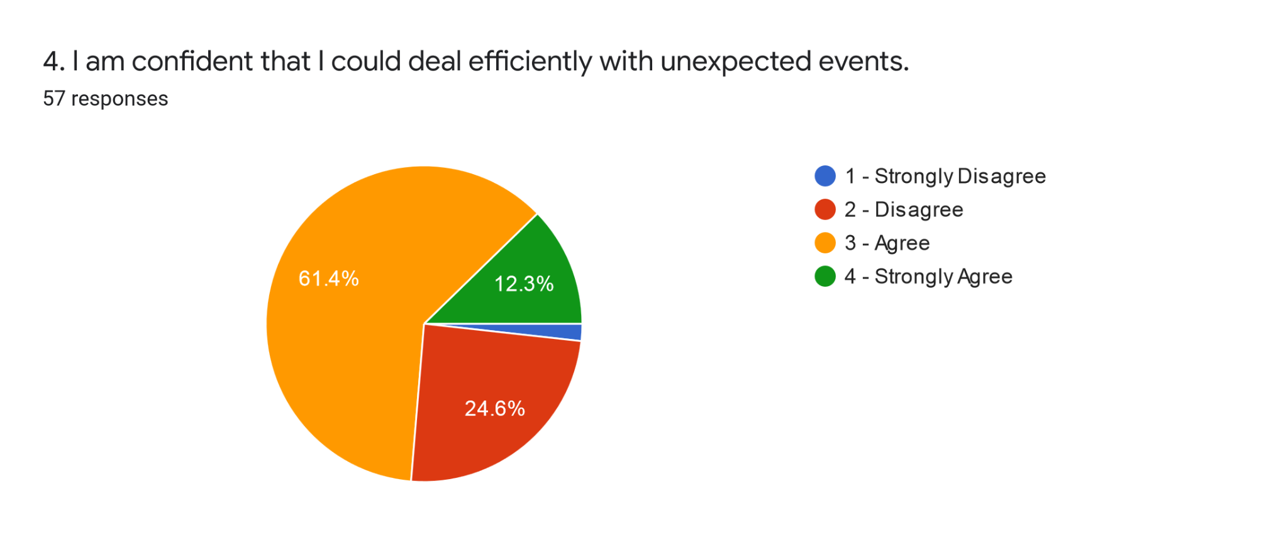

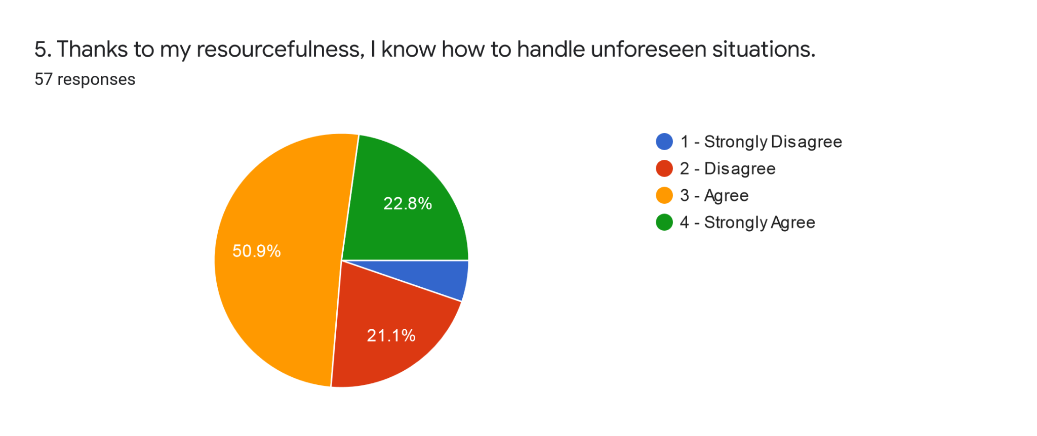

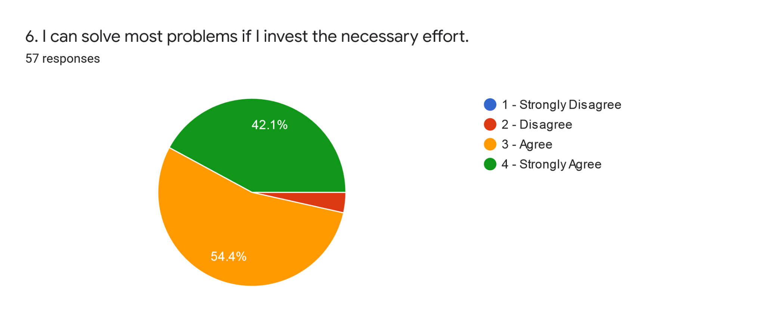

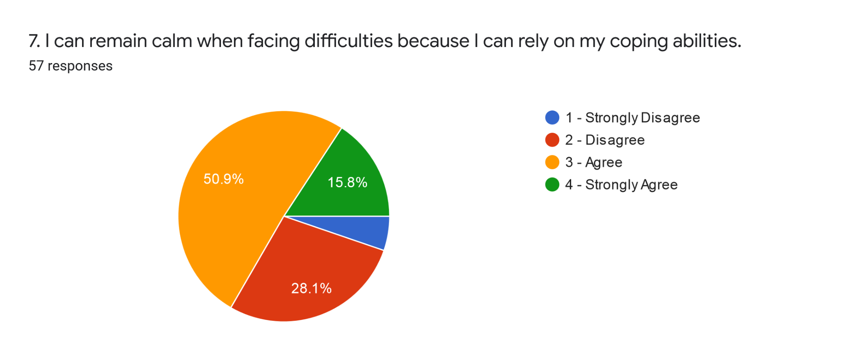

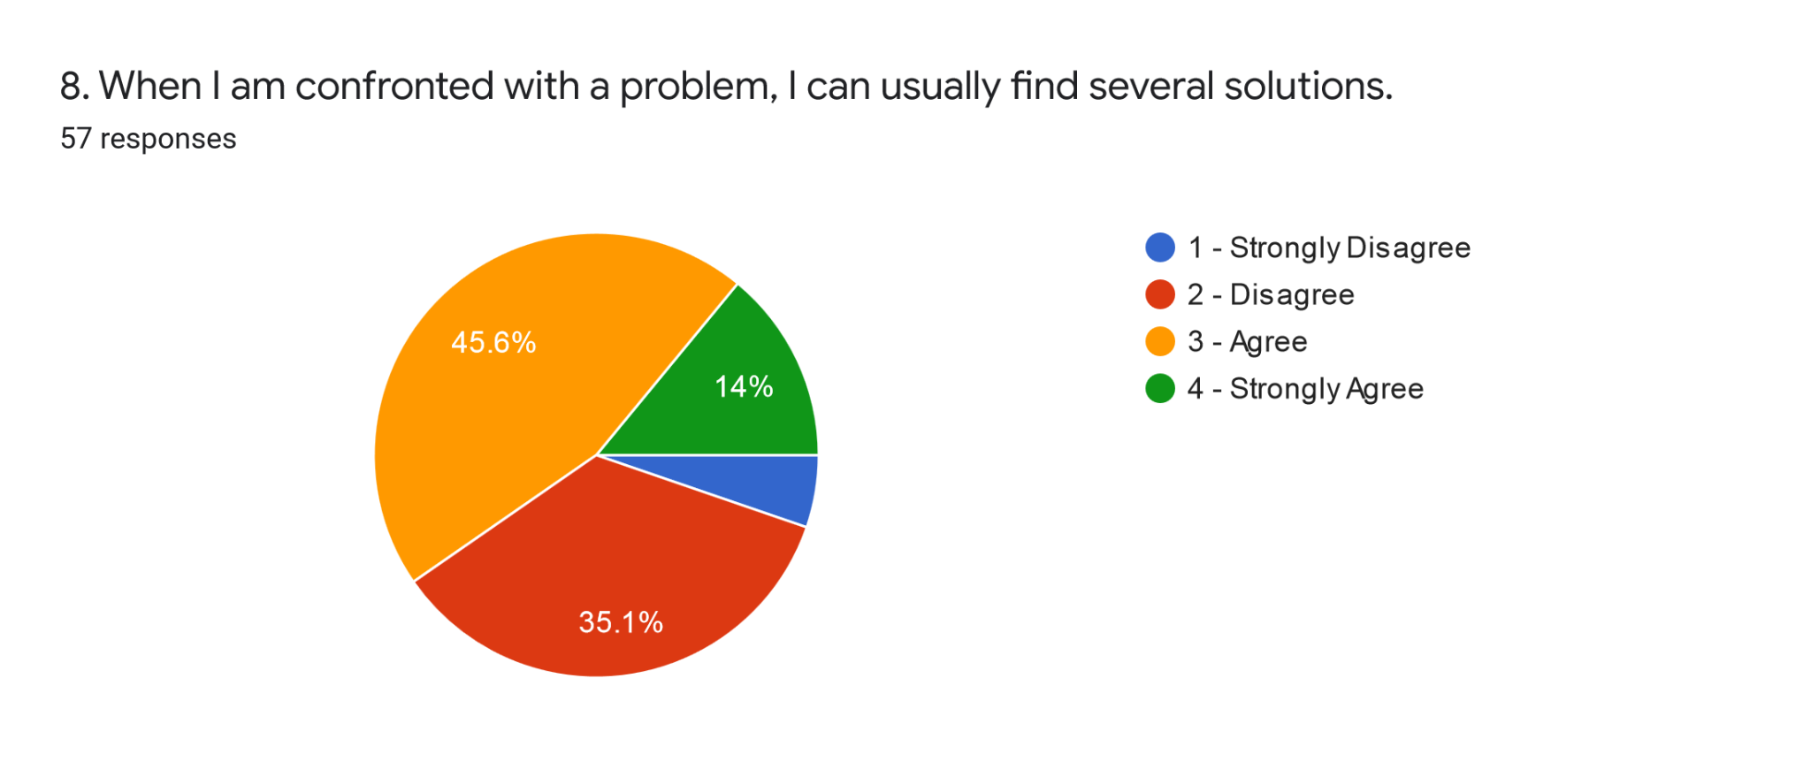

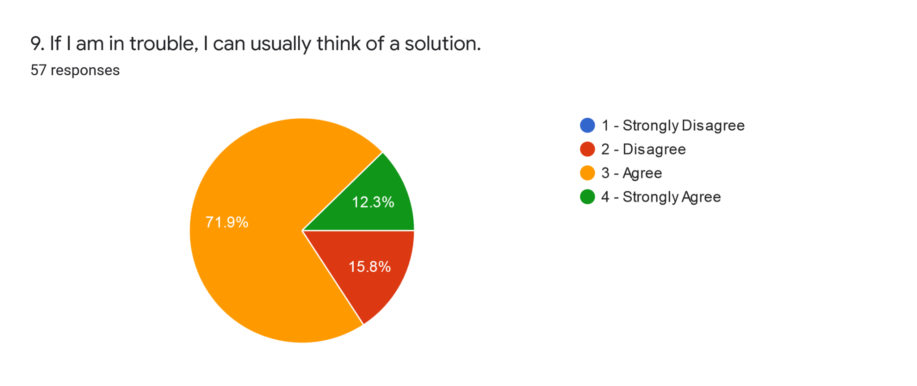

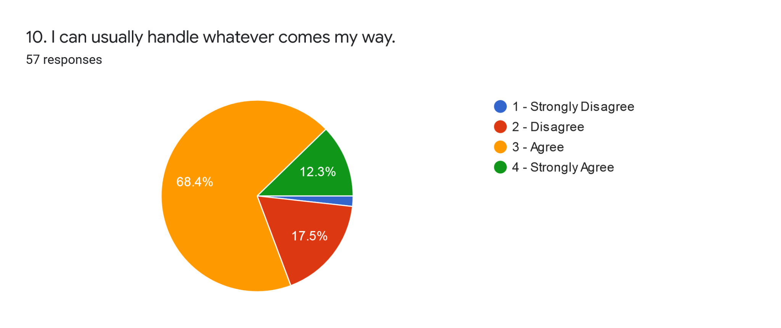

**Personal Experience within Small-Learning Community Results:**

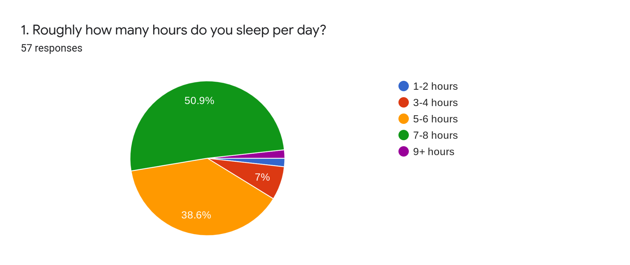

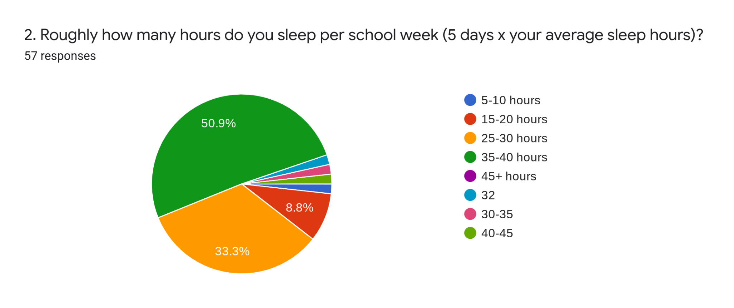

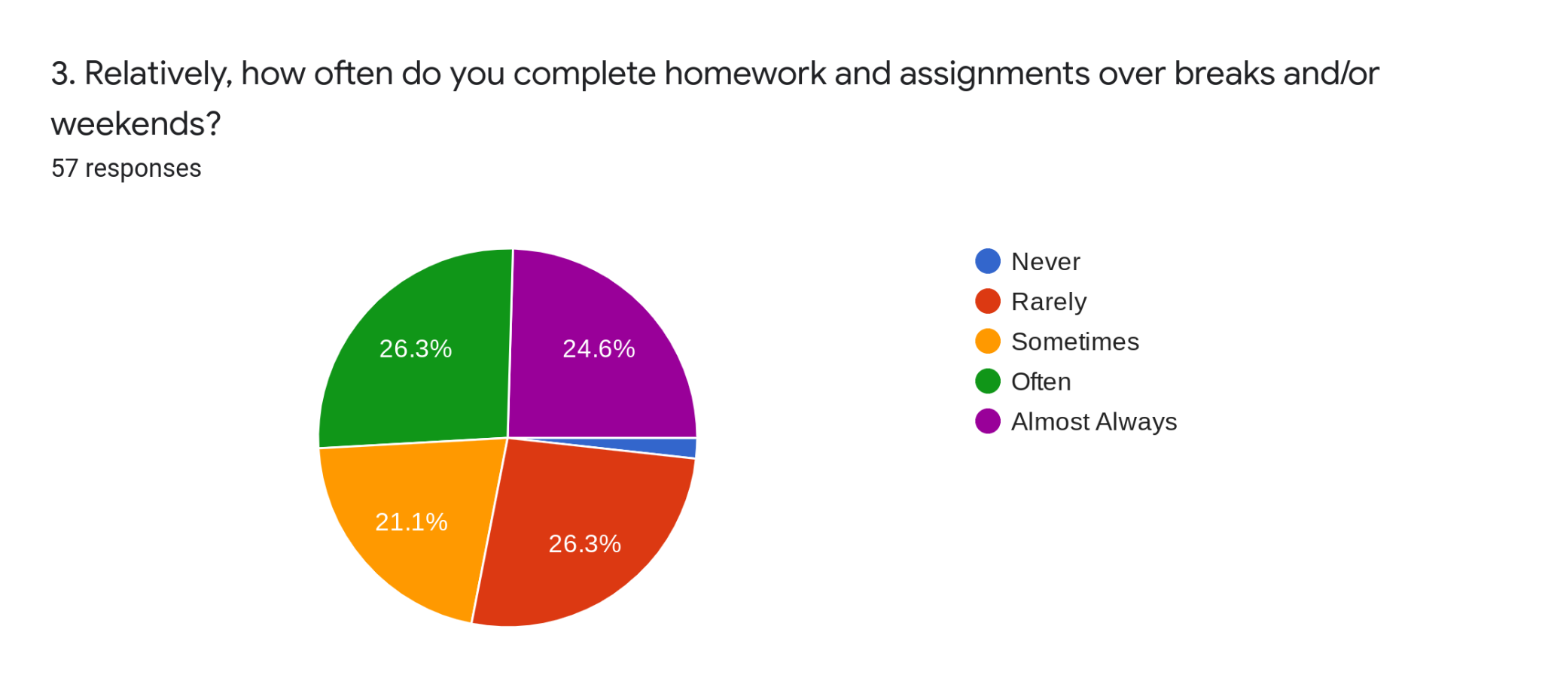

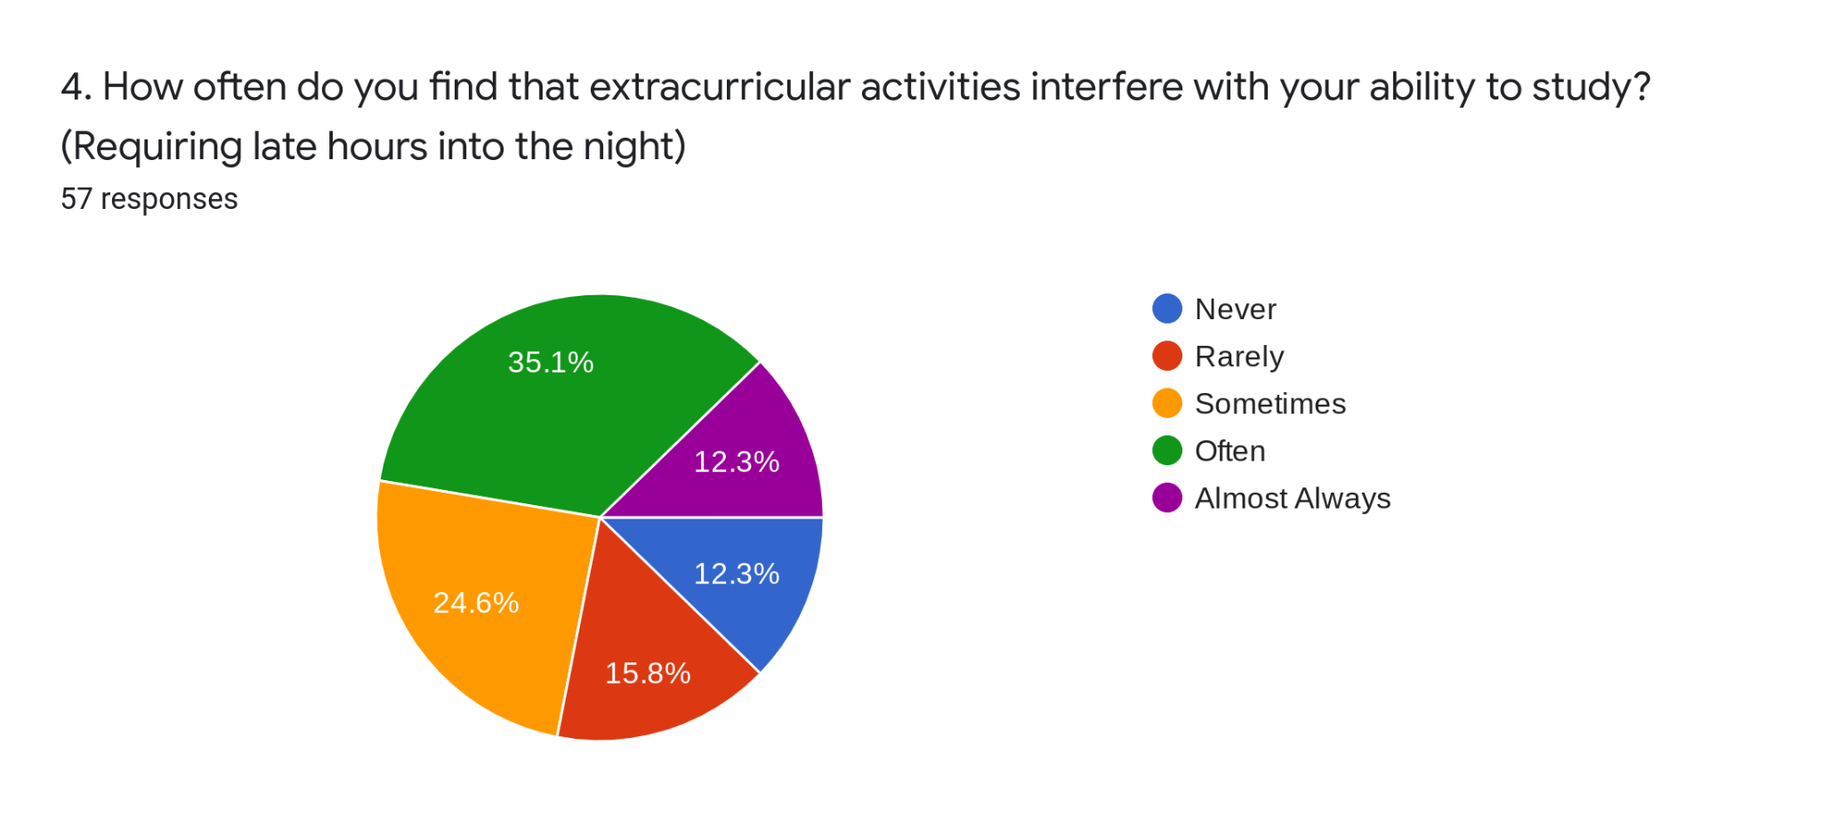

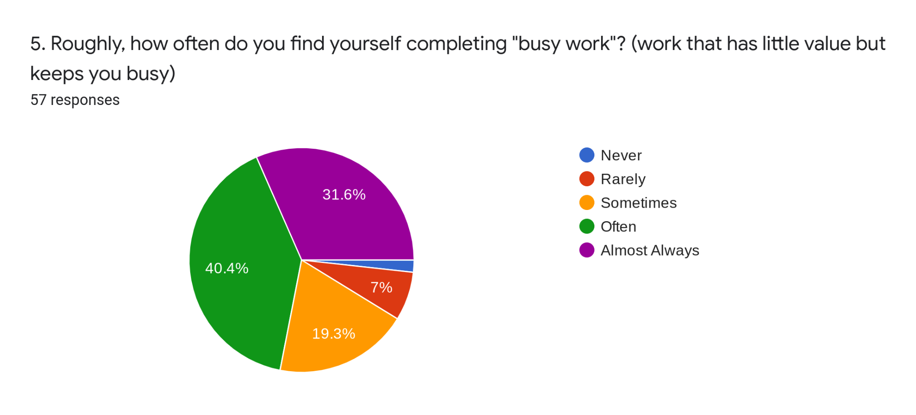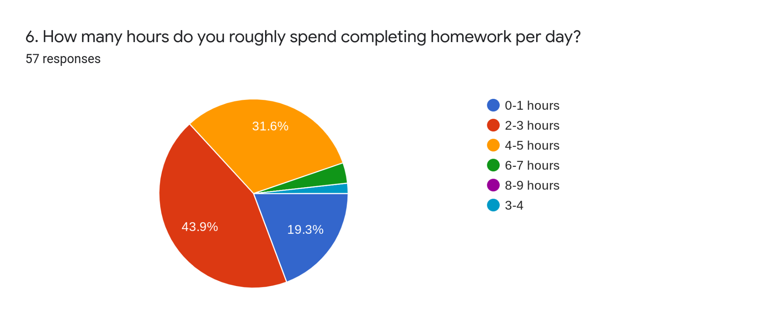

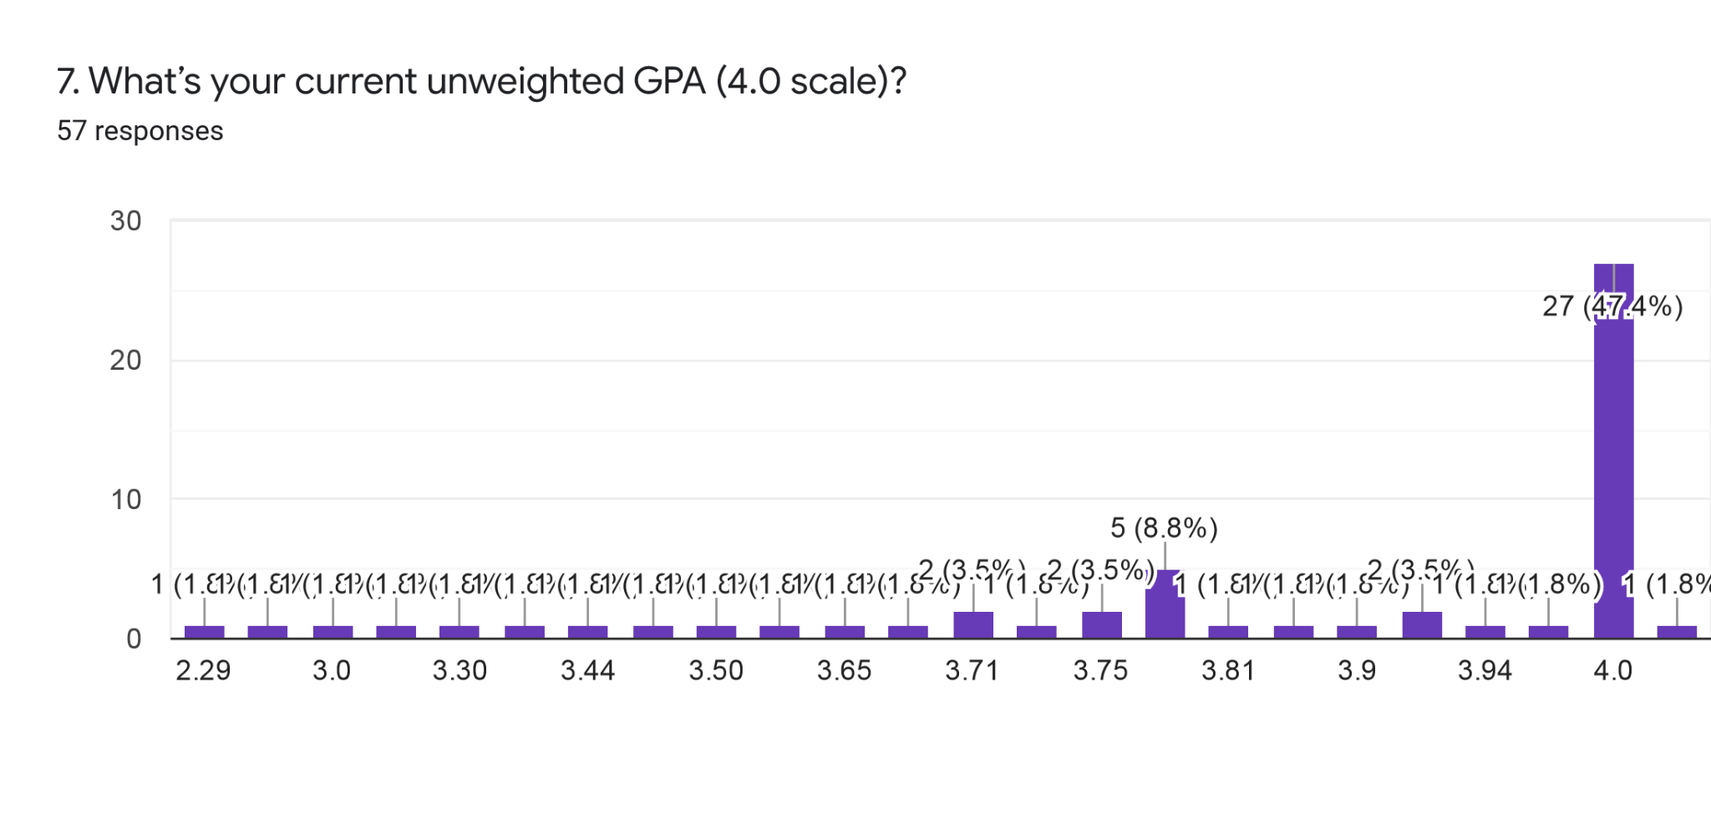

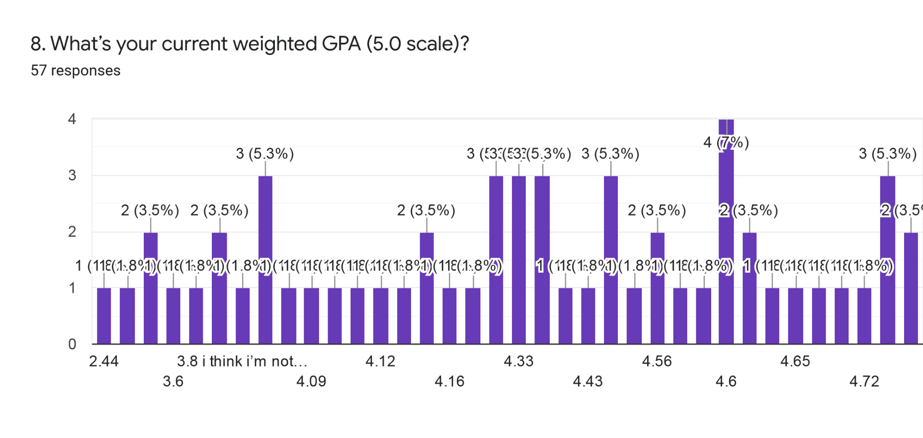

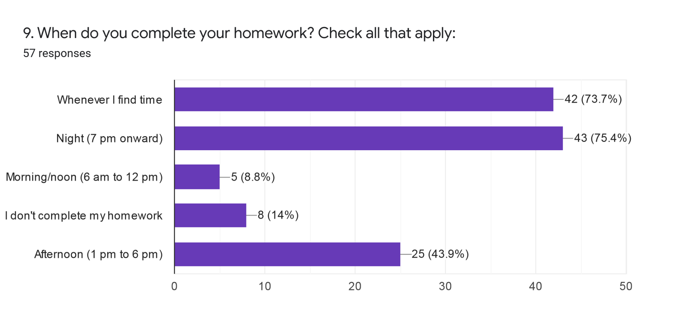

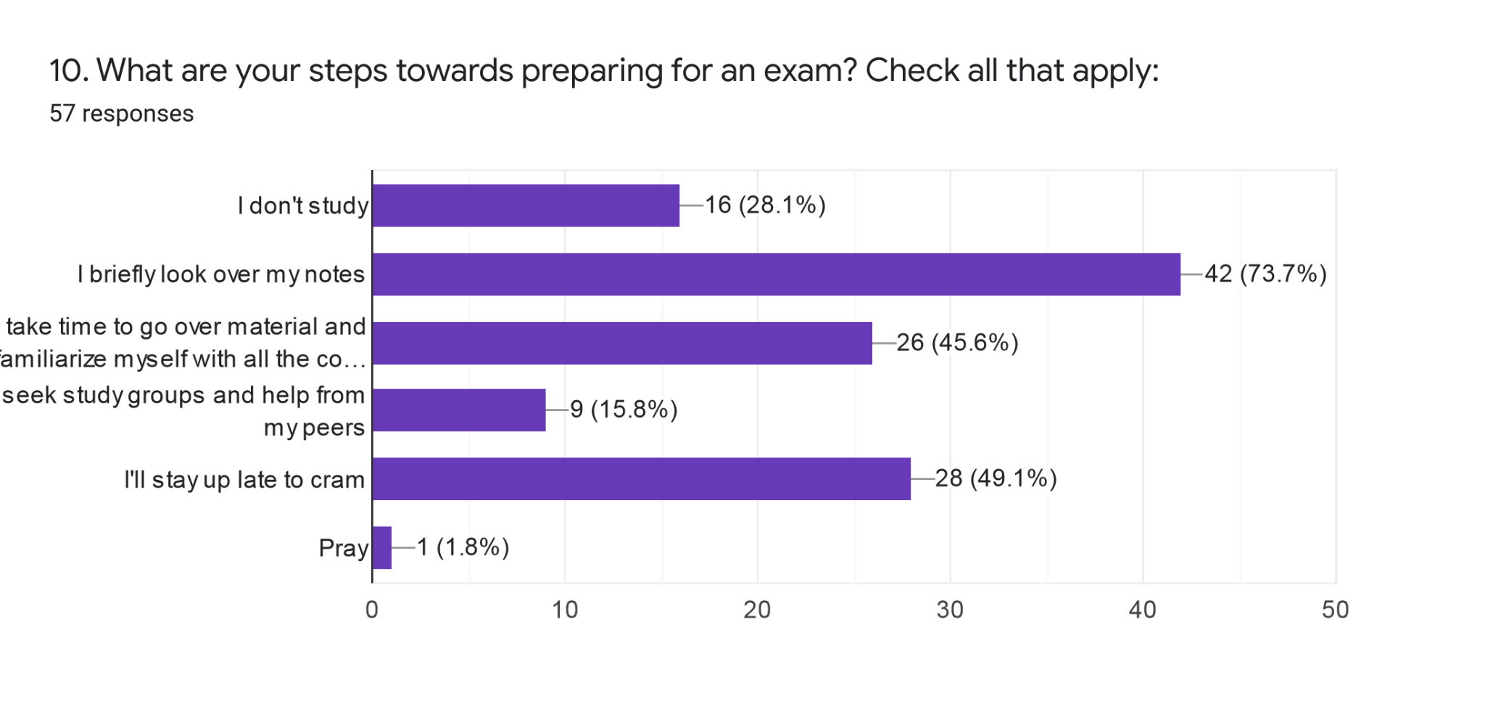

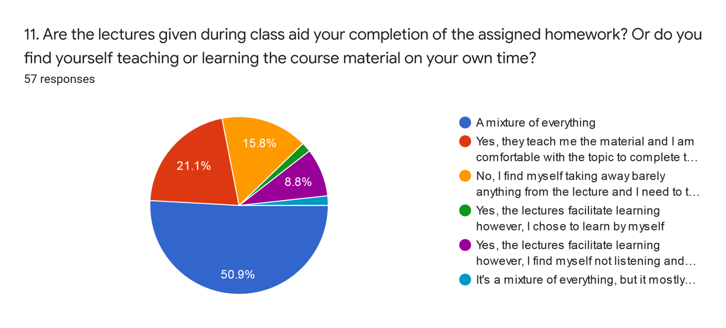

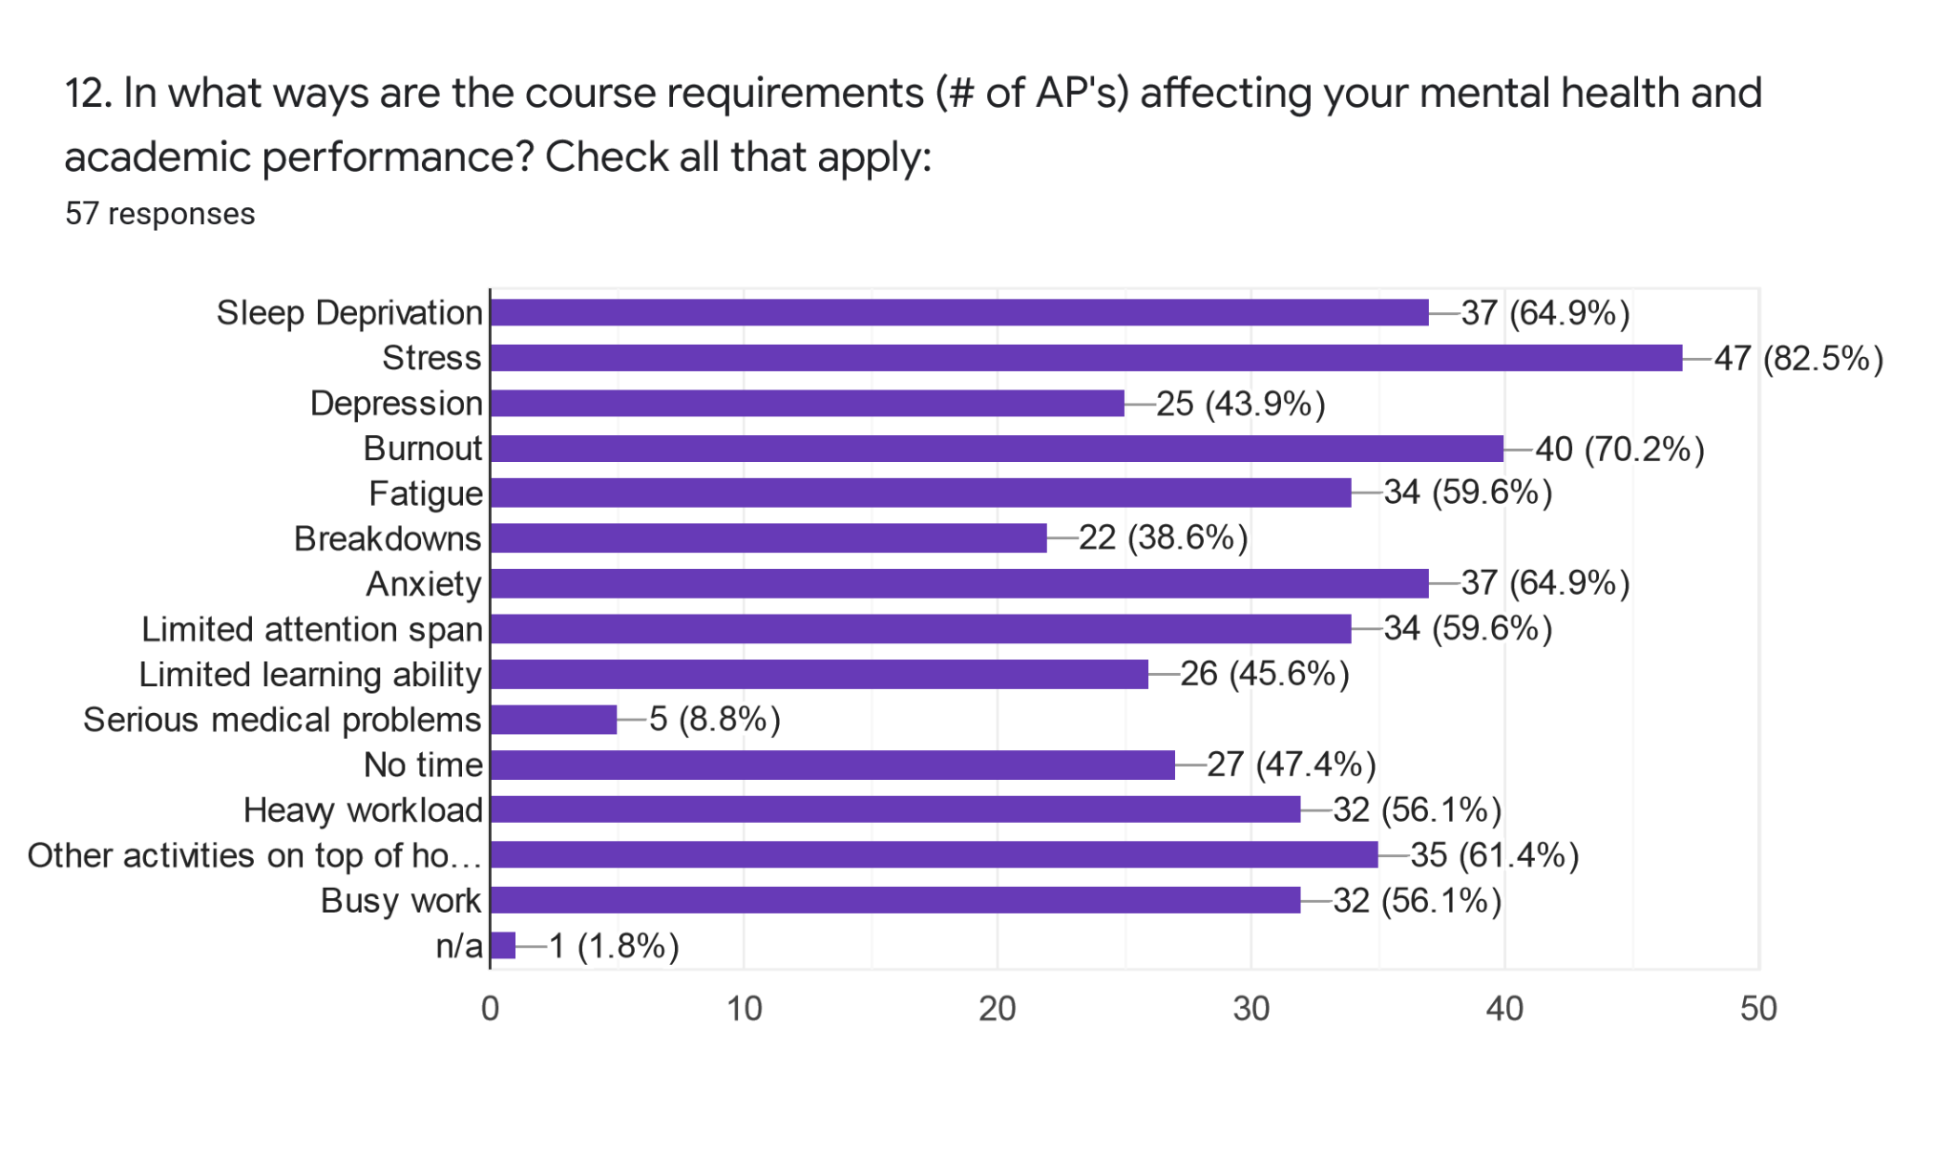

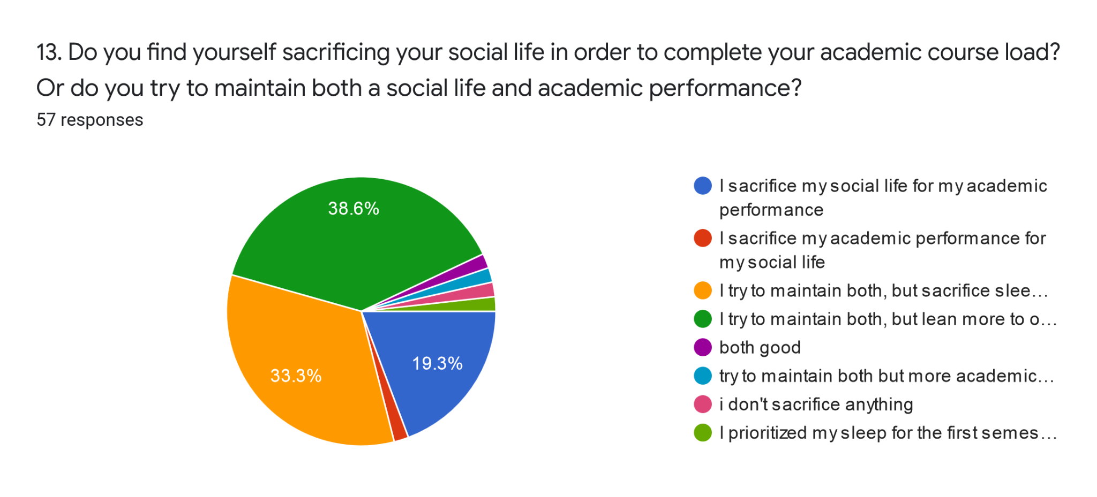

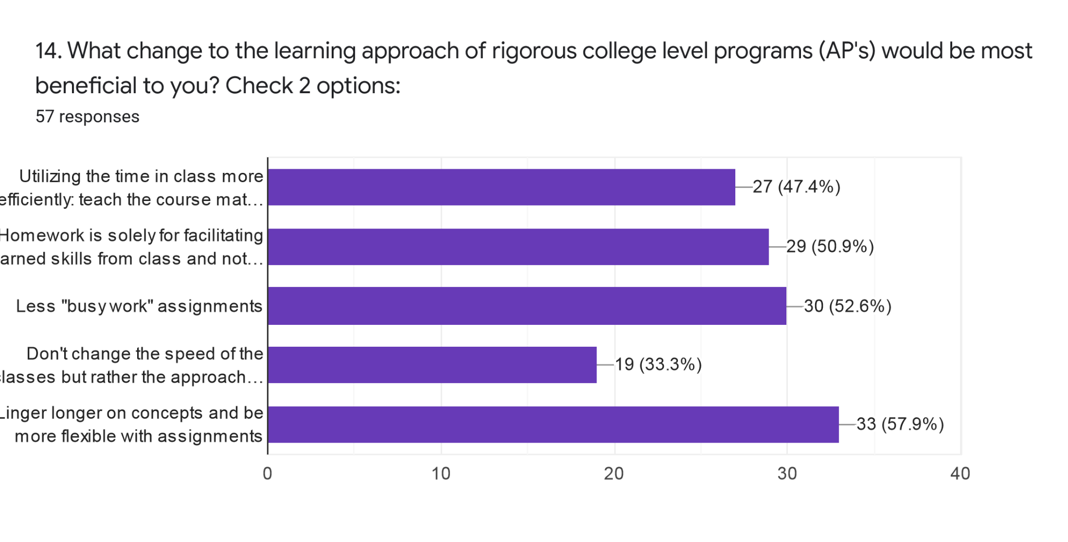

**Interview**

Thank you for participating in my research study! Before we get started, if you don't mind reviewing this consent form just in case you decide not to participate which is not bad but it includes all the disclaimers but purpose of what we are doing today. I will be audio taping this interview but only for me only to take it and transcribe what you said into actual wording on a paper rather than audio. This will be deleted once I do so and you will remain anonymous. Try to answer in as much detail as possible and don’t feel afraid to announce no comment.

Questions:

1. What are your thoughts regarding the requirements of this pathway you are in? Do you agree with the layout of AP classes, for example 1 in your freshman year, 1-2 in your sophomore, 4 in your junior, and 5-6 in your senior year? If not, elaborate why.

| Q. 1: Agree with Layout |  | Overwhelming | Stressful/Pressure |  | Too many AP's | Structure Change |  | Option for AP Diversity |  |
| --- | --- | --- | --- | --- | --- | --- | --- | --- | --- |
| Yes however | | N/A | N/A | | N/A | Yes | | Yes | |
| No | | Yes | Yes | | Yes | Yes | | N/A | |
| No | | Yes | Yes | | Yes | Yes | | Yes | |
| No | | Yes | Yes | | Yes | Yes | | N/A | |
| No | | Yes | Yes | | Yes | Yes | | N/A | |
| Yes | | N/A | N/A | | No | No | | N/A | |
| Yes however | | N/A | Yes | | No | Yes | | Yes | |
| Yes | | N/A | N/A | | N/A | No | | N/A | |
| Yes however | | Yes | N/A | | Yes | Yes | | Yes | |
| No | | N/A | Yes | | N/A | No | | N/A | |
| No | | N/A | N/A | | No | Yes | | Yes | |
| Yes however | | N/A | Yes | | Yes | No | | Yes | |
| Yes however | | N/A | N/A | | Yes | Yes | | N/A | |
| Yes however | | Yes | N/A | | N/A | Yes | | N/A | |
| No | | Yes | Yes | | Yes | Yes | | N/A | |
| No | | Yes | Yes | | Yes | Yes | | N/A | |
| No | | Yes | Yes | | Yes | Yes | | N/A | |
| No | | N/A | N/A | | N/A | Yes | | N/A | |

1. When you are overwhelmed with schedules and assignments, what is the first thing you choose to sacrifice? For example, sleep, hanging out with friends, family time?

| Grade | WAVE | Gender | Q: 1 Sacrifice | | Additional |
| --- | --- | --- | --- | --- | --- |
| 12 | yes | M | Self Enjoyment | |  |
| 12 | yes | F | Sleep | | Social Life |
| 12 | yes | F | Self Enjoyment | | Social Life |
| 12 | yes | F | Family Time | |  |
| 12 | yes | F | Sleep | |  |
| 12 | yes | M | Sleep | |  |
| 12 | yes | M | Sleep | |  |
| 12 | yes | F | Sleep | |  |
| 12 | yes | M | Self Enjoyment | | Social Life |
| 12 | yes | F | All + other classes homeworks | |  |
| 12 | yes | F | Sleep | | Social Life |
| 11 | yes | M | Self Enjoyment | | Extracurriculars |
| 10 | yes | F | Sleep | | Social Life |
| 9 | yes | M | Social Life | |  |
| 9 | yes | M | Self Enjoyment | |  |
| 12 | no | F | Sleep | | Social Life |
| 12 | no | F | Sleep | |  |
| 12 | no | F | Self Enjoyment | |  |

1. When you entered high school, did you feel a massive discrepancy (away from your normal schedule) in your sleep schedule? If so, what caused it? Was it by choice such as procrastination or too much homework; a mix of both?

| Grade | WAVE | Gender | Q. 3 Which Schedule Changed | | Too much work/Demanding | | Procrasination |
| --- | --- | --- | --- | --- | --- | --- | --- |
| 12 | yes | M | Yes, extracurriculars | | Similar to Middle School | | N/A |
| 12 | yes | F | Yes, homework time | | Yes | | Yes |
| 12 | yes | F | Yes, sleep + hw | | Yes | | N/A |
| 12 | yes | F | Yes, homework time | | Yes | | N/A |
| 12 | yes | F | Yes, sleep + hw | | Yes | | N/A |
| 12 | yes | M | Yes, sleep + hw | | Yes | | N/A |
| 12 | yes | M | Yes, sleep + hw | | N/A | | N/A |
| 12 | yes | F | Yes, extracurriculars + hw | | Yes | | N/A |
| 12 | yes | M | No | | Similar to Middle School | | N/A |
| 12 | yes | F | Yes, sleep + hw | | Yes | | Yes |
| 12 | yes | F | Yes, sleep + hw | | Yes | | Yes |
| 11 | yes | M | Yes, extracurriculars + hw | | Yes | | N/A |
| 10 | yes | F | Yes, sleep + hw | | Yes | | Yes |
| 9 | yes | M | Yes, sleep + hw | | Yes | | Yes |
| 9 | yes | M | No | | N/A | | No |
| 12 | no | F | Yes, sleep + hw | | Yes | | N/A |
| 12 | no | F | Yes, sleep + hw | | Yes | | N/A |
| 12 | no | F | No, I was already going through it | | Yes | | Yes |

1. Are you partaking in any extracurricular activities within school or outside of school? Do they affect when you start studying or how you study? For example, late nights, or completing work wherever you are.

| Q: 4 Extracurricular |  | Where hours are spent: | | Time | Still in it? | Result on studying | |
| --- | --- | --- | --- | --- | --- | --- | --- |
| Rugby | | Outside of school | | Multiple hrs | Yes | Pressed for time | |
| Swim, Orchestra, Karate | | Both | | Multiple hrs | Dropped 2 | Overwhelmed | |
| Ballet, Dance | | Both | | Multiple hrs | Dropped 1 | late nights + time consuming | |
| Clubs | | In School | | Multiple hrs | Sacrifice 1 | Stressed | |
| Band | | In School | | Multiple hrs | Yes | Pressed for time | |
| Swim, Waterpolo | | Both | | Multiple hrs | Yes | No affect | |
| Swim | | Both | | Multiple hrs | Yes | No affect | |
| Volleyball, Clubs | | Both | | Multiple hrs | Yes | Overwhelmed | |
| Baseball | | Both | | Multiple hrs | Yes | late nights + time consuming | |
| Clubs | | In School | | Multiple hrs | Dropped | time consuming | |
| Swim | | In School | | Multiple hrs | Dropped | late nights + time consuming | |
| Orchestra, Swim, Clubs | | Both | | Multiple hrs | Yes | time consuming | |
| Soccer | | Both | | Multiple hrs | Yes | late nights + time consuming | |
| Soccer | | Both | | Multiple hrs | Yes | late nights + time consuming | |
| Soccer | | Both | | Multiple hrs | Yes | No affect | |
| Clubs | | Both | | Multiple hrs | Yes | time consuming | |
| Soccer, Clubs | | In School | | Multiple hrs | Yes | time consuming | |
| Clubs | | Both | | Multiple hrs | Yes | time consuming | |

1. There is something called the Forced Choice Dilemma. It is the belief held by some intellectually gifted students that they must choose between academic achievement and peer acceptance or in other words, their academic life vs their social life. Do you experience this?

| Grade | WAVE | Gender | Q. 5 Forced Choice Dilemma Choice | | | Both? |
| --- | --- | --- | --- | --- | --- | --- |
| 12 | yes | M | School over social life | | | No |
| 12 | yes | F | School over social life | | | Attempts |
| 12 | yes | F | School over social life | | | Attempts |
| 12 | yes | F | School over social life | | | No |
| 12 | yes | F | School over social life | | | No |
| 12 | yes | M | Balance both | | | Achieved |
| 12 | yes | M | School over social life | | | Attempts |
| 12 | yes | F | School over social life | | | Attempts |
| 12 | yes | M | Balance both | | | Attempts |
| 12 | yes | F | School over social life | | | Attempts |
| 12 | yes | F | School over social lfie | | | Attempts |
| 11 | yes | M | Balance both | | | Attempts |
| 10 | yes | F | Balance both | | | Attempts |
| 9 | yes | M | Balance both | | | Achieved |
| 9 | yes | M | Balance both | | | Achieved |
| 12 | no | F | School over social life | | | Attempts |
| 12 | no | F | Social life over school | | | Attempts |
| 12 | no | F | Social life over school | | | No |

1. How has your experience within this pathway been throughout your time here at Wilson?

| Grade | WAVE | Gender | Q. 6 Experience Within AP Courses/Pathway | | |
| --- | --- | --- | --- | --- | --- |
| 12 | yes | M | All right | | |
| 12 | yes | F | Stressful, no teacher acknowledgement | | |
| 12 | yes | F | Beneficial despite the competition | | |
| 12 | yes | F | Stressful but beneficial | | |
| 12 | yes | F | Stressful but beneficial | | |
| 12 | yes | M | All right | | |
| 12 | yes | M | Stressful but beneficial | | |
| 12 | yes | F | Stressful but beneficial | | |
| 12 | yes | M | Stressful but beneficial | | |
| 12 | yes | F | Stressful = cheating | | |
| 12 | yes | F | Stressful but beneficial | | |
| 11 | yes | M | Beneficial | | |
| 10 | yes | F | Beneficial despite the competition | | |
| 9 | yes | M | All right, teacher upgrades | | |
| 9 | yes | M | All right | | |
| 12 | no | F | Beneficial despite need for better teachers | | |
| 12 | no | F | Stressful but beneficial | | |
| 12 | no | F | Stressful because of the teachers | | |

1. Do you think your mental health has been impacted from being involved in this program? In what ways? Do you think it has affected your academic performance?

| Grade | WAVE | Gender | Mental Health Impact | | Academic Performance Impact | | |
| --- | --- | --- | --- | --- | --- | --- | --- |
| 12 | yes | M | No | | Not impacted | | |
| 12 | yes | F | Anxiety, lack of focus, sleep | | Not impacted, sacrifices mental health | | |
| 12 | yes | F | Anxiety | | Sometimes affected but sacrifices mental health | | |
| 12 | yes | F | Anxiety, on edge, irritation | | Not impacted, sacrifices mental health | | |
| 12 | yes | F | Stressed | | Impacted, focus wise and scores | | |
| 12 | yes | M | Gone down | | Not impacted | | |
| 12 | yes | M | Stressed | | Not impacted, sacrifices mental health | | |
| 12 | yes | F | Anxiety, stress | | Sometimes affected but sacrifices mental health | | |
| 12 | yes | M | Stressed, inability to relax | | Not impacted, sacrifices mental health | | |
| 12 | yes | F | Lack of sleep, lack of focus | | Impacted, focus wise and scores | | |
| 12 | yes | F | Severe depression, anxiety, sleep | | Impacted, focus wise and scores | | |
| 11 | yes | M | No | | Not impacted | | |
| 10 | yes | F | Stressed, sleep, breakdowns | | Not impacted, sacrifices mental health | | |
| 9 | yes | M | No | | Not impacted | | |
| 9 | yes | M | No | | Not impacted | | |
| 12 | no | F | Gone down | | Not impacted, sacrifices mental health | | |
| 12 | no | F | Gone down | | Sometimes affected but sacrifices mental health | | |
| 12 | no | F | Pressure, lack of focus | | Impacted, focus wise and scores | | |

1. If you were to change anything about this pathway, what would it be? How can the teaching methods be improved if they can be?

| Grade | WAVE | Gender | Q. 8 Areas for Improvement | | |  |  |  |  |  |
| --- | --- | --- | --- | --- | --- | --- | --- | --- | --- | --- |
| 12 | yes | M | Choice for more elective based AP's | | |  |  |  |  |  |
| 12 | yes | F | Less pressure on testing, learn the topics | | |  |  |  |  |  |
| 12 | yes | F | Teacher approach towards students outside life | | |  |  |  |  |  |
| 12 | yes | F | Inform students the AP structure so they can plan | | |  |  |  |  |  |
| 12 | yes | F | Less AP's, teacher's teach instead of just hw/tests or student self-teaching | | | | |  |  |  |
| 12 | yes | M | Less hw, more classwork (projects) | | |  |  |  |  |  |
| 12 | yes | M | Less hw, teacher's teach (notes in class) | | |  |  |  |  |  |
| 12 | yes | F | No busy work, open-minded and shared grading system, teacher support, different AP choices, notes in class and not at home | | | | | | | |
| 12 | yes | M | Limit work, focus on lectures in class | | |  |  |  |  |  |
| 12 | yes | F | Teaching method to be by the book | | |  |  |  |  |  |
| 12 | yes | F | Less hw | | |  |  |  |  |  |
| 11 | yes | M | Limit hw | | |  |  |  |  |  |
| 10 | yes | F | Change the AP distribution | | |  |  |  |  |  |
| 9 | yes | M | Work in class, finish assignments as hw not another topic | | | |  |  |  |  |
| 9 | yes | M | Make AP requirements less harsh | | |  |  |  |  |  |
| 12 | no | F | Approach teaching fast paced info more efficient | | |  |  |  |  |  |
| 12 | no | F | Less work, focus more in class not at home | | |  |  |  |  |  |
| 12 | no | F | Place value on understanding concepts instead of a high value on test scores | | | | | |  |  |